<https://www.questpond.com/demo.html>

What is Angularjs? See picture below

https://video.search.yahoo.com/yhs/search;_ylt=AwrDQ3KDKv9bUm4Ai9Y0nIlQ;_ylu=X3oDMTBncGdyMzQ0BHNlYwNzZWFyY2gEdnRpZAM-;_--?gprid=13Qlhc8OQZe5WbjkqK1VRA&pvid=7CGp.zEwLjFf3cdUW_xCk07jNzEuMQAAAABGcNZ9&p=angular+8+in+1+hour+by+kudvenkat&ei=UTF-8&fr2=p%3As%2Cv%3Av%2Cm%3Asa&fr=yhs-iba-1&hsimp=yhs-1&hspart=iba&type=43nt_7906_CHW_US#id=9&vid=ca5ba7af39a4eaa2dfb217bd81dbfb8f&action=view

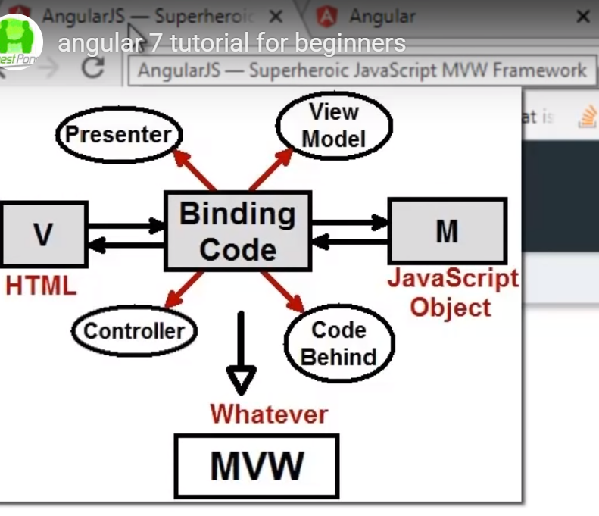

What is Angular? Angular is a binding framework

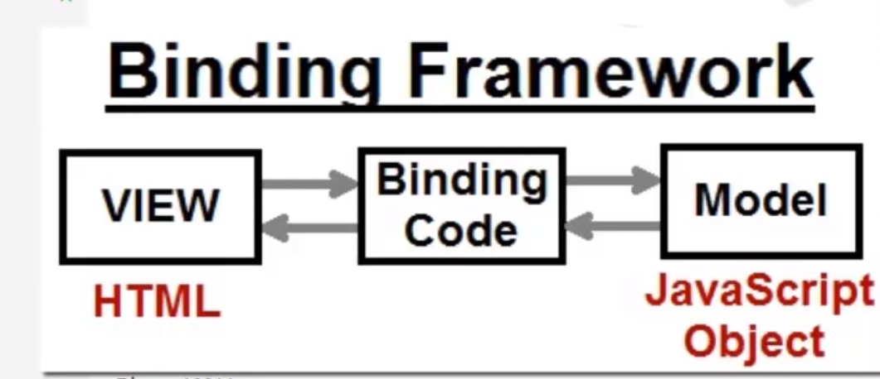

Angular is saying we are one framework which can be used for Mobile and Desktop

So,

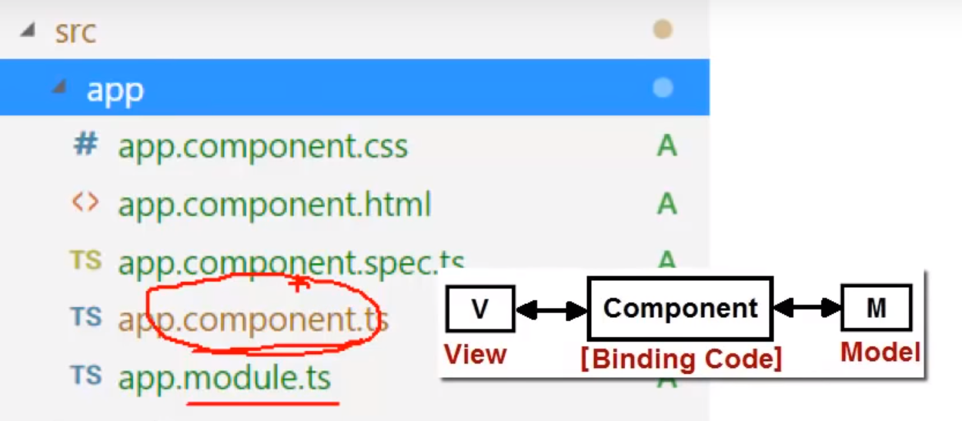

So, the component receives data from the View/UI in the form of events and sends data to the UI

As indicated below, a group of components are called/termed as module

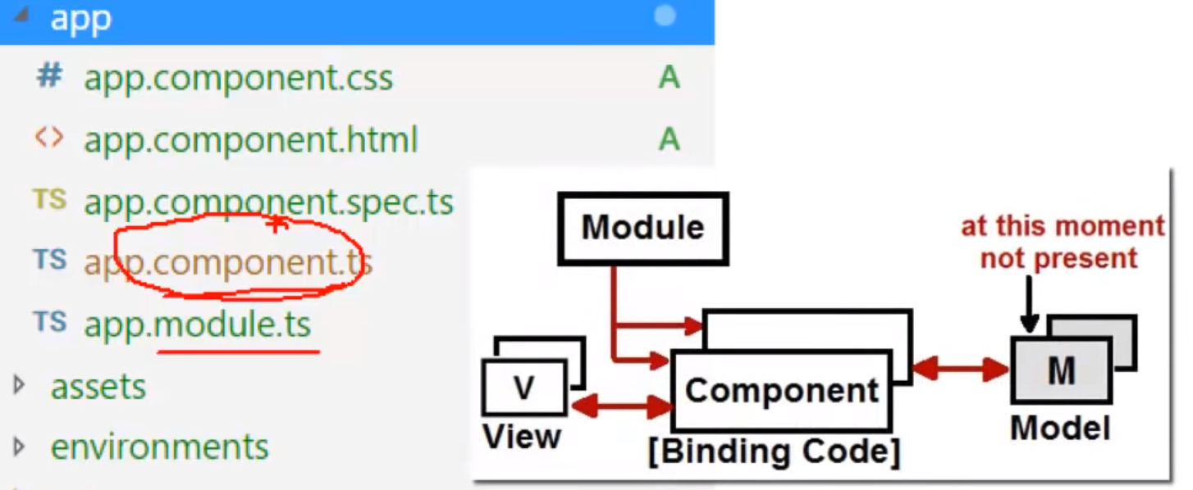

Now let us see at app.component.ts

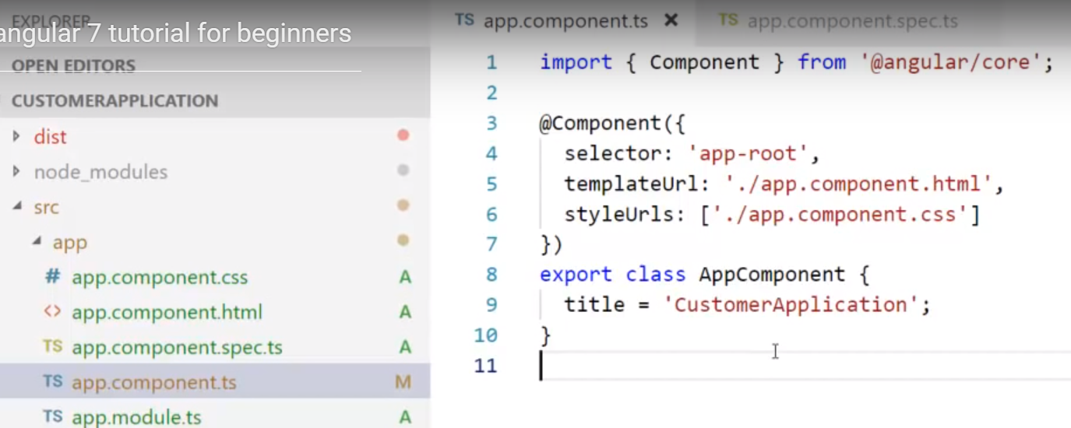

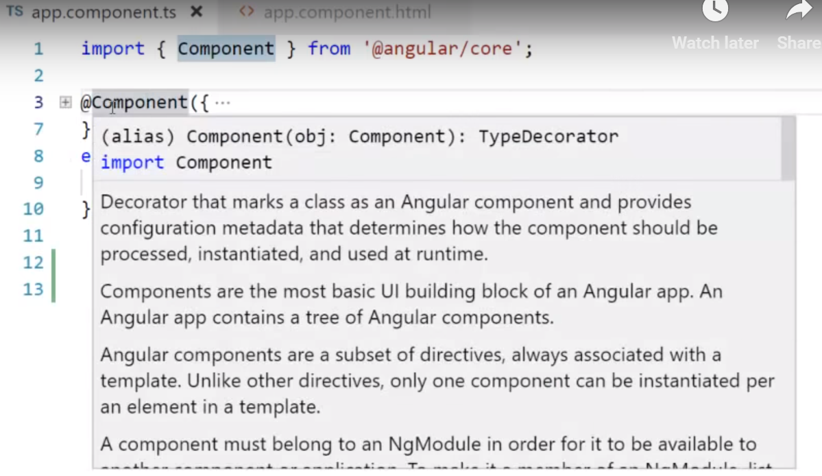

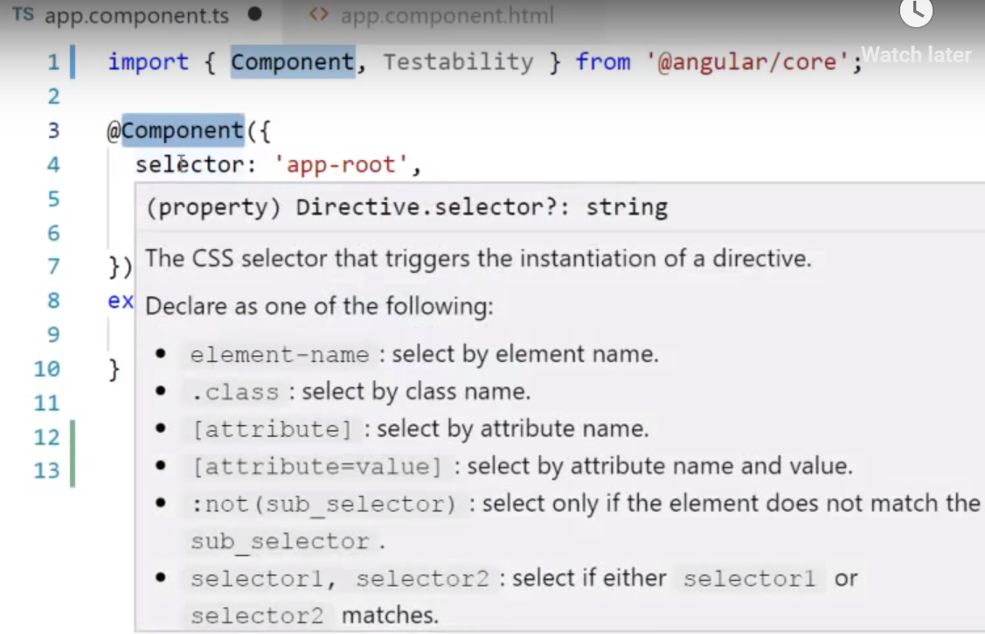

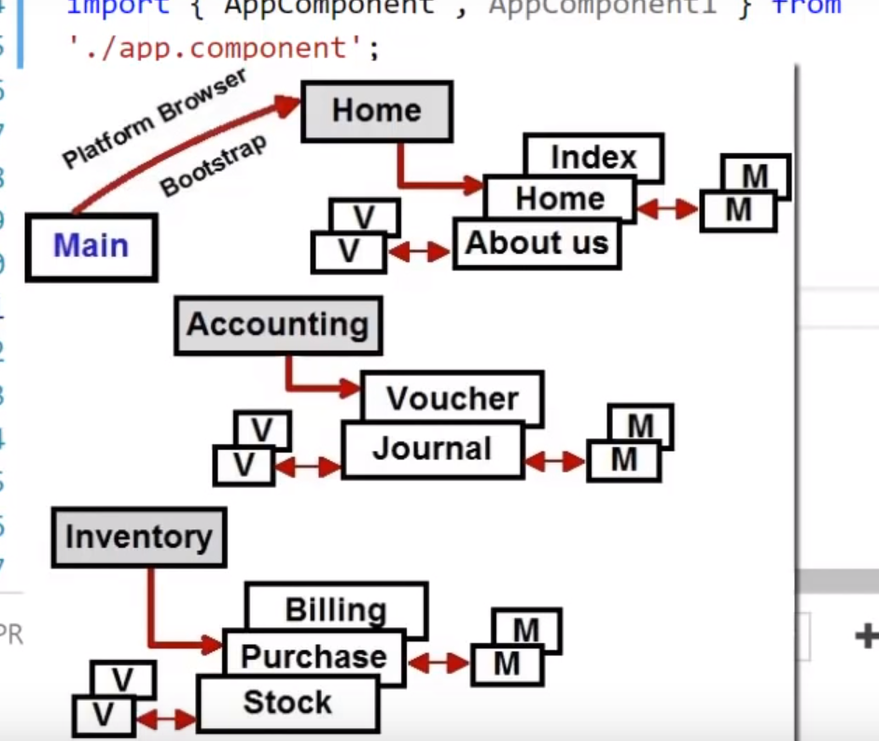

Main.ts is the bootstrap that starts running the app or it defines the start up file of your project

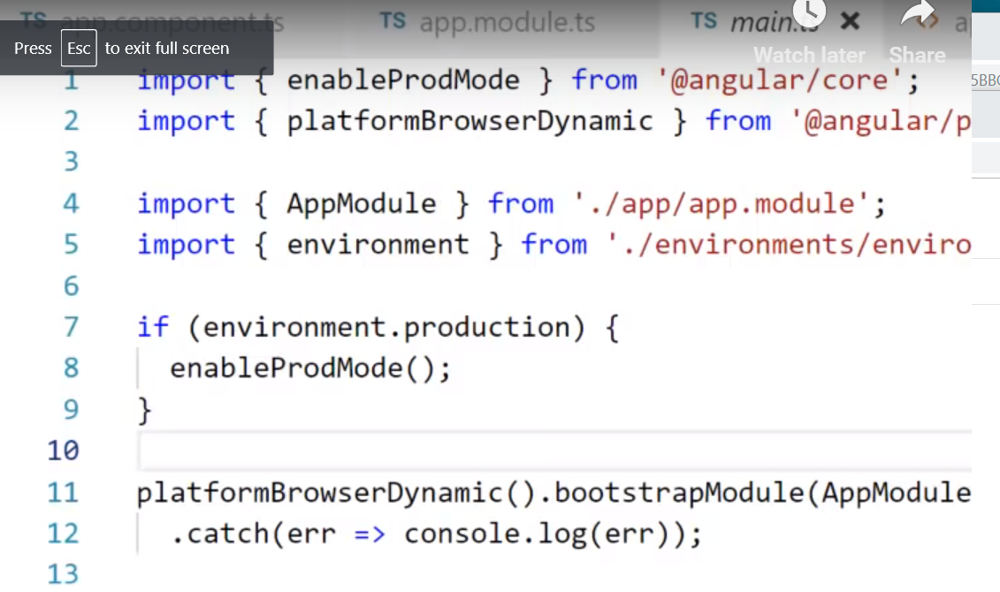

Let us see the start up flow:

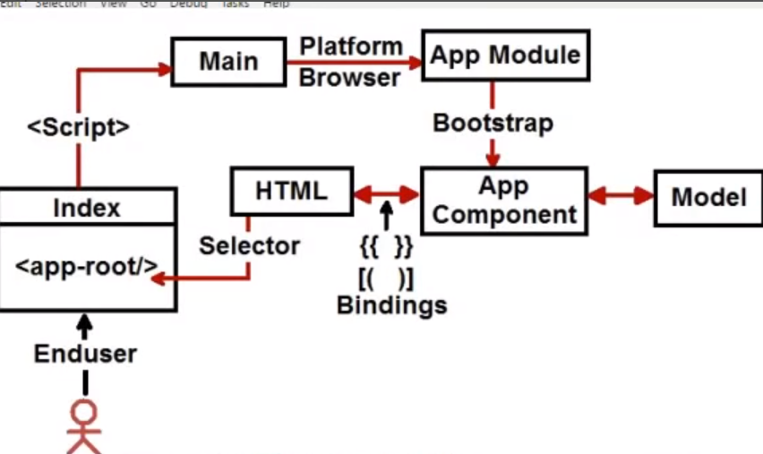

Look at the app.component.html below:

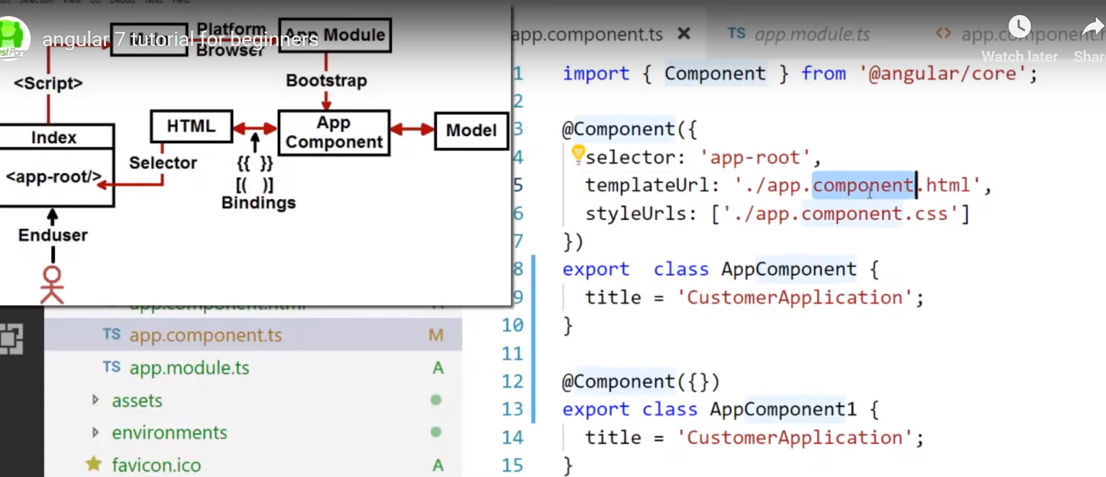

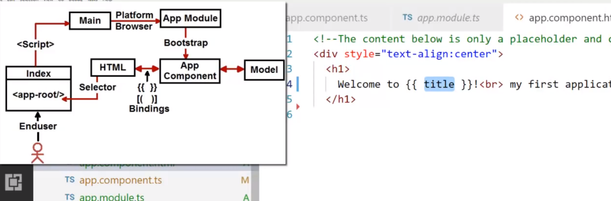

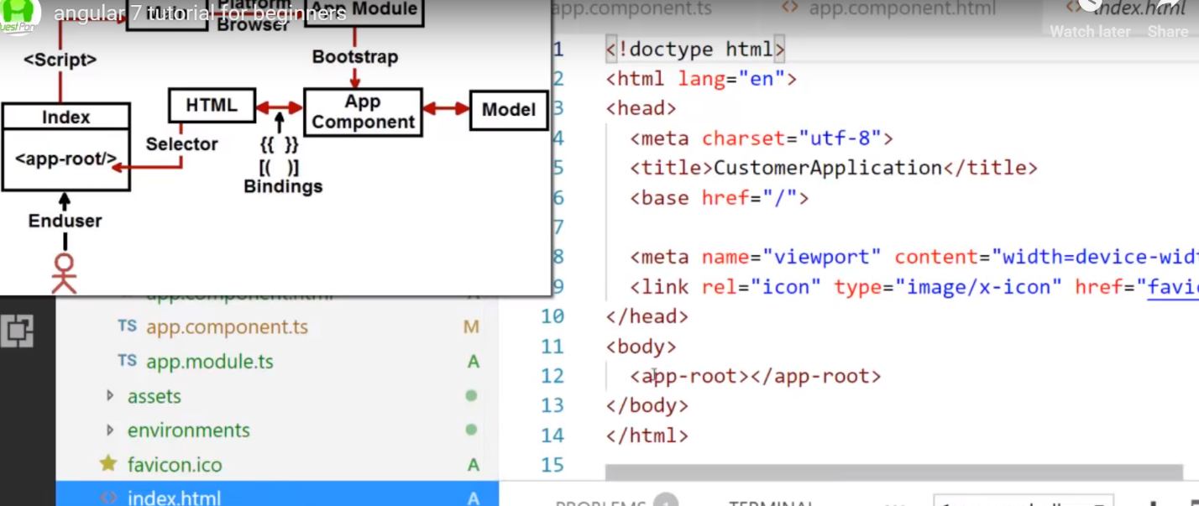

Load the html inside the following selector:

This selector says load app.component.html inside the below selector

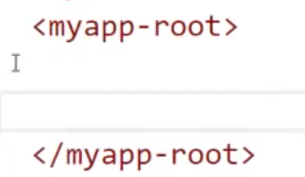

Which inside index.html. So, the following app.componet.html is inserted/loded in the above <myapp-root> selector as shown below:

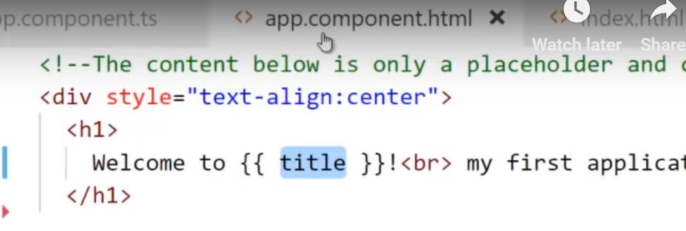

Or 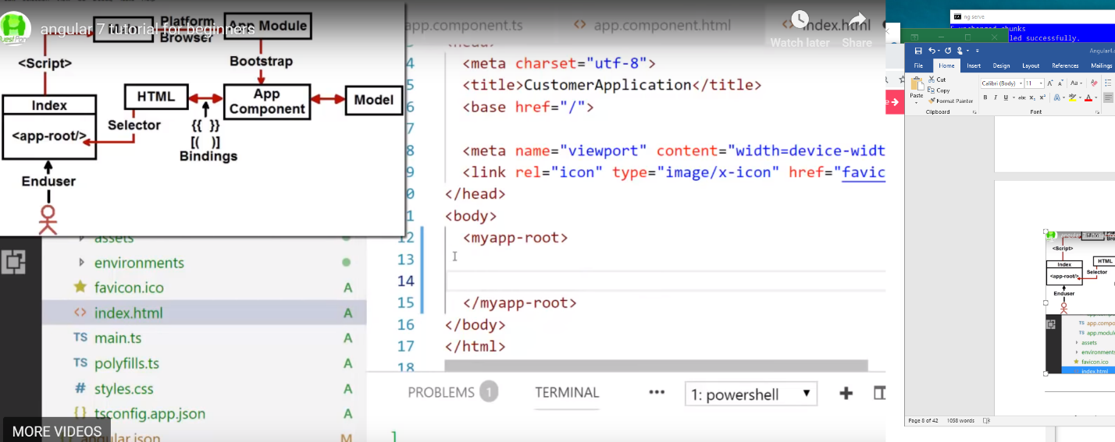

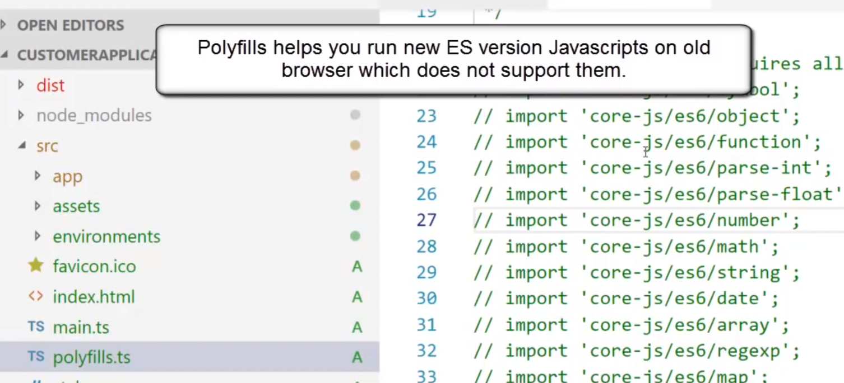

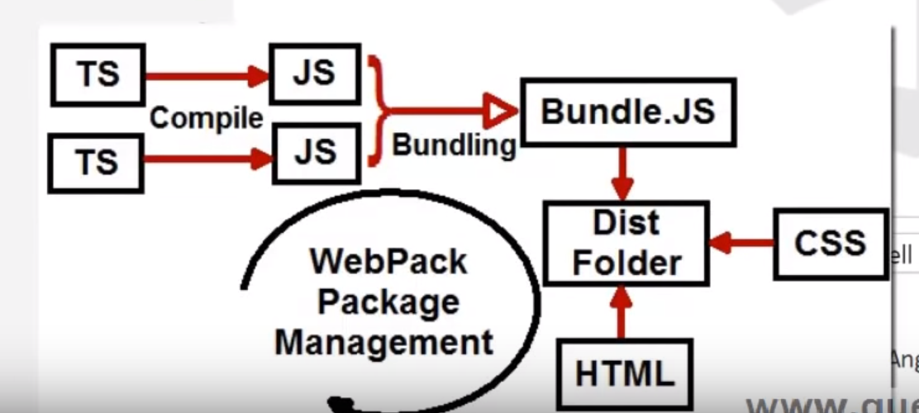

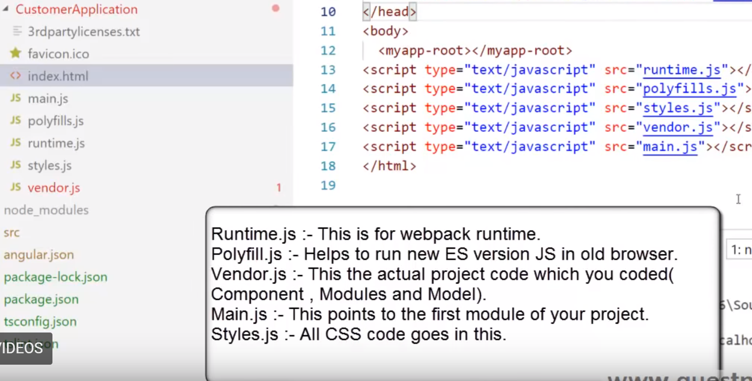

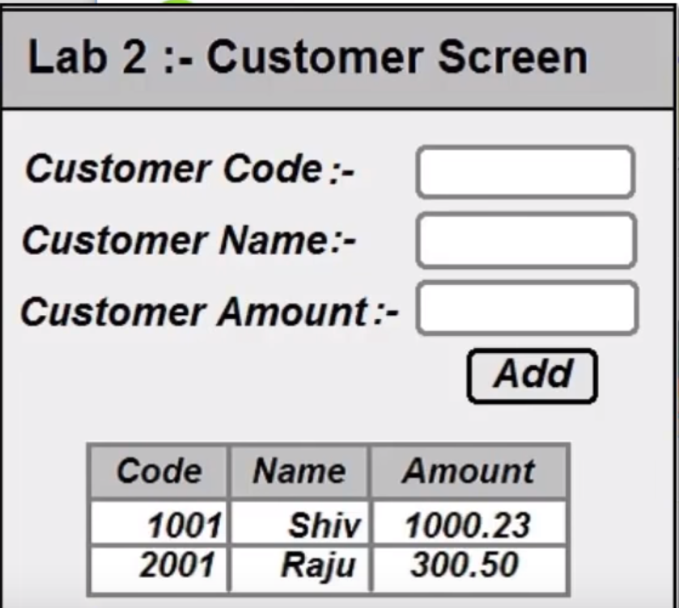

Source of Angular

<http://www.pragimtech.com/download_kudvenkat_angular_tutorial_videos.aspx>

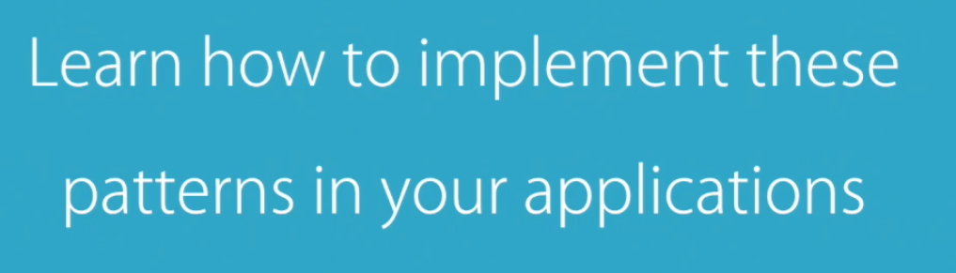

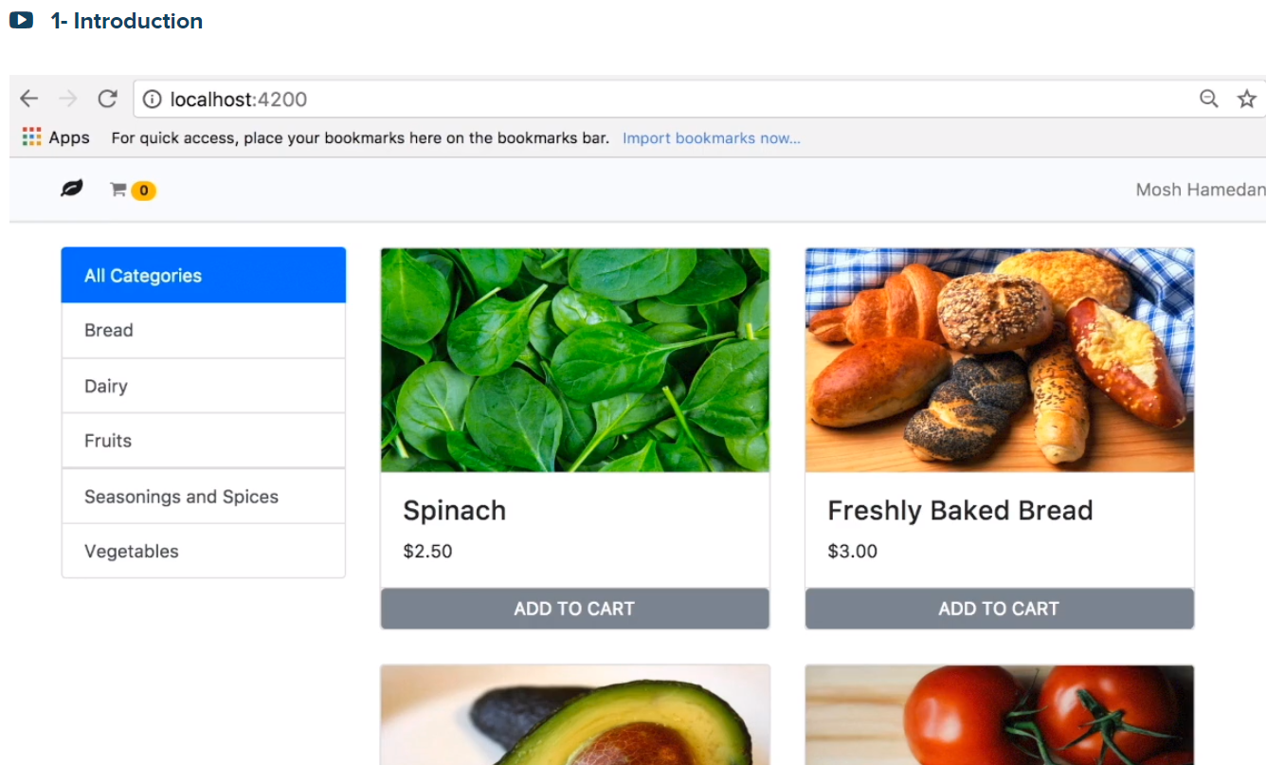

Click on Fruits to see the list of fruits products

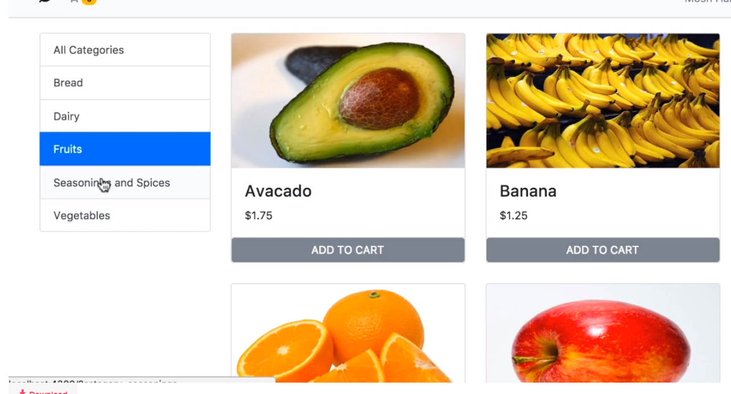

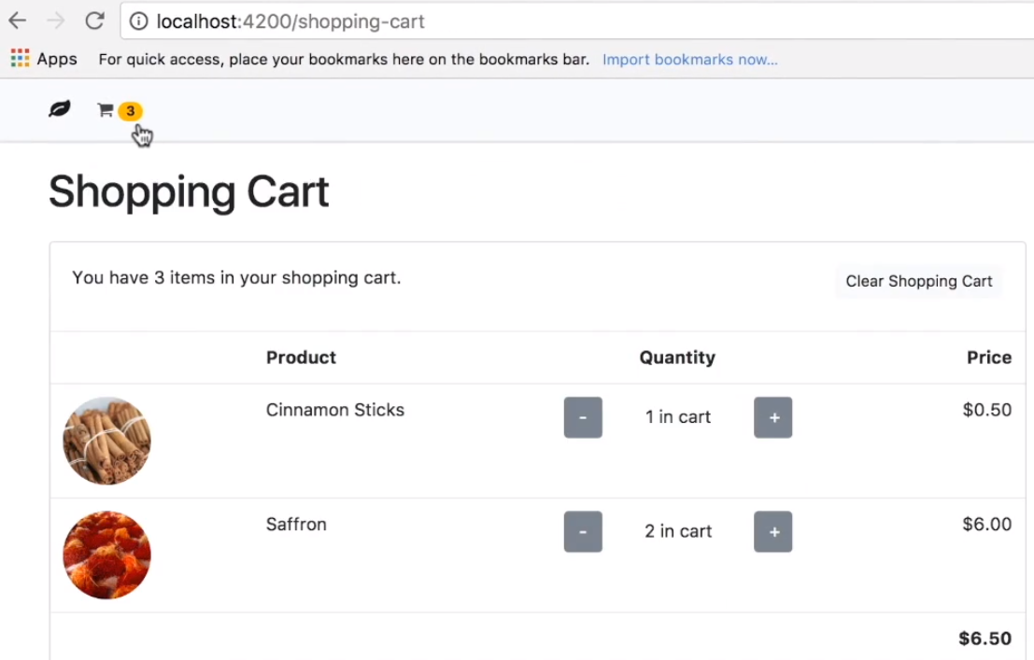

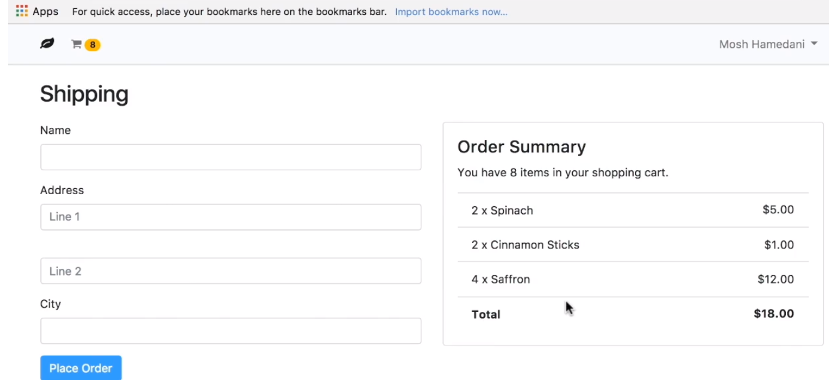

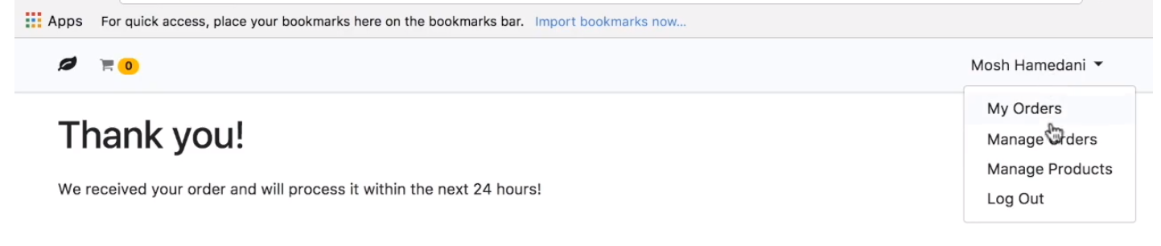

As an admin manage the Orders and Products

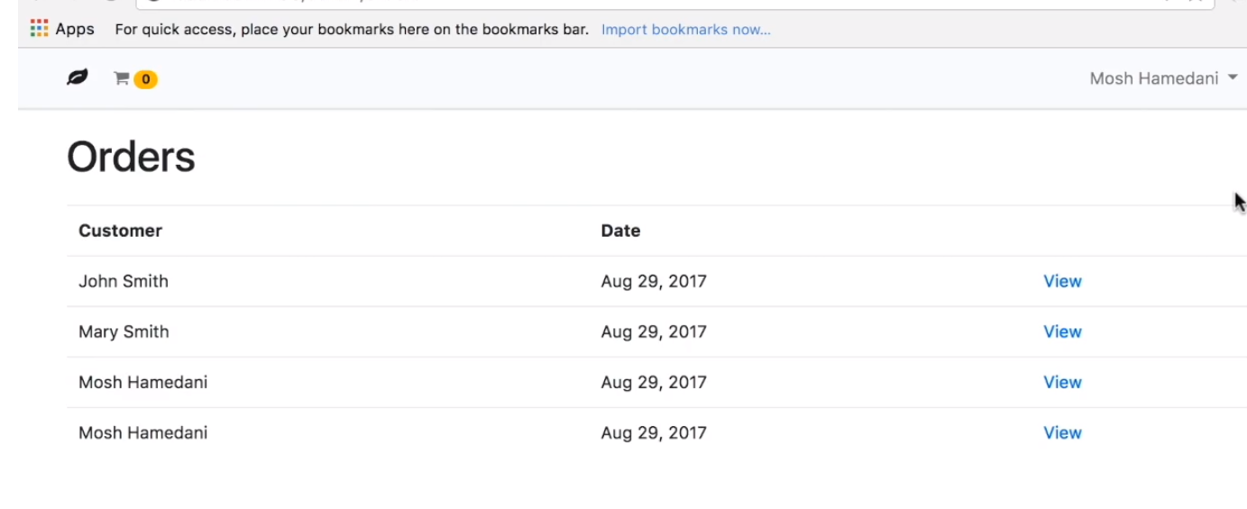

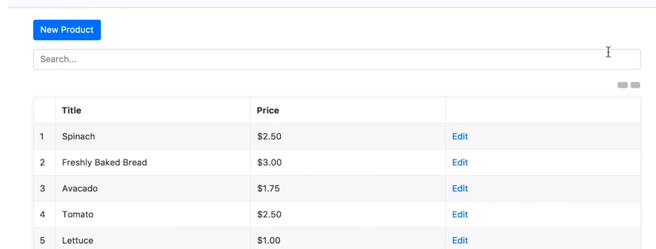

What is Angular?

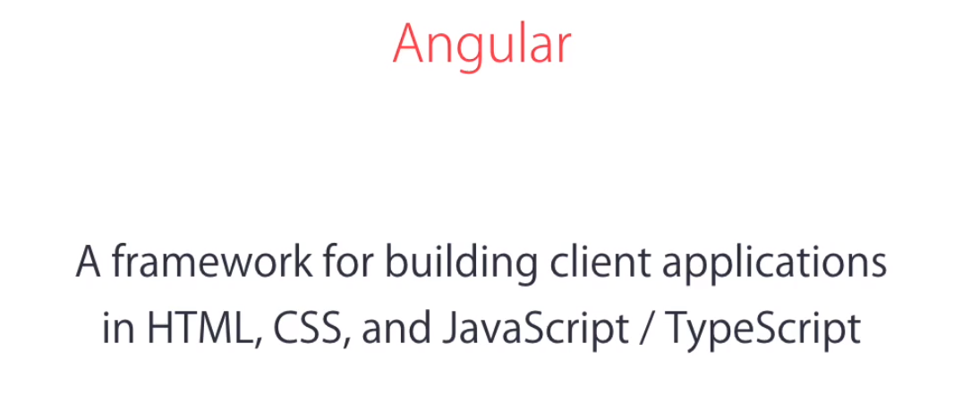

Why do we need Angular?

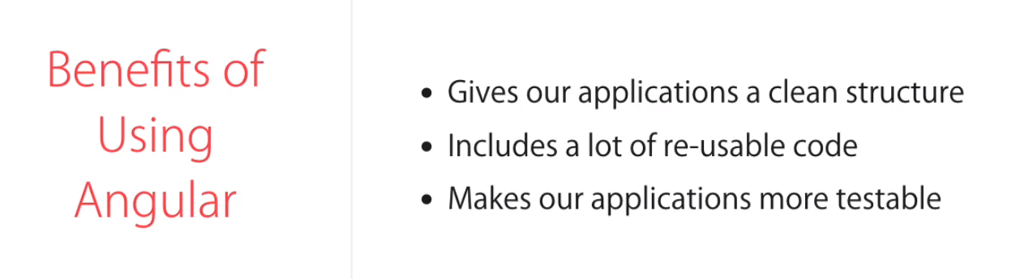

Angular Makes your life easier



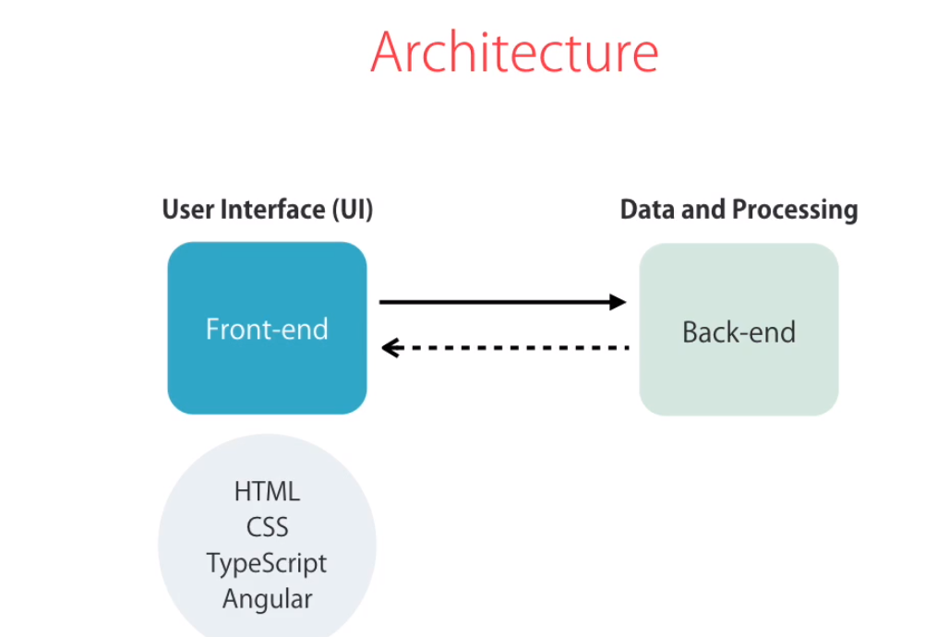



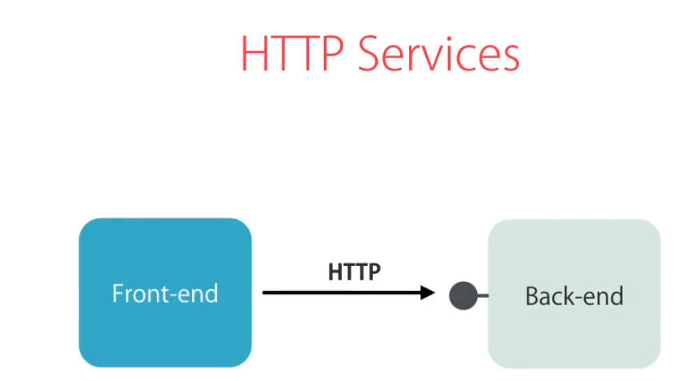

More example in real world:

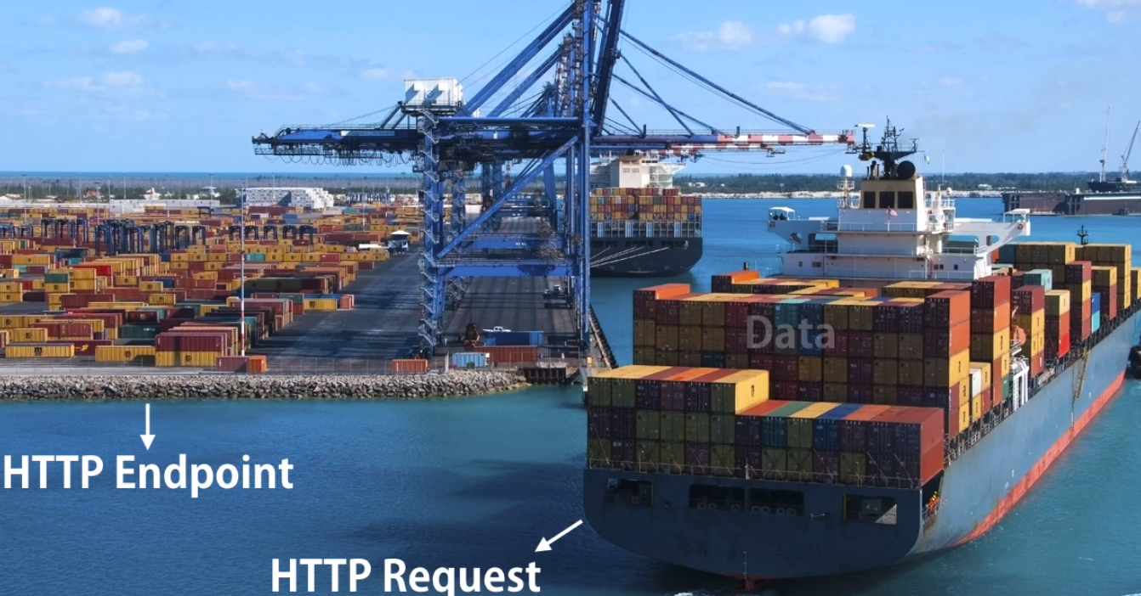

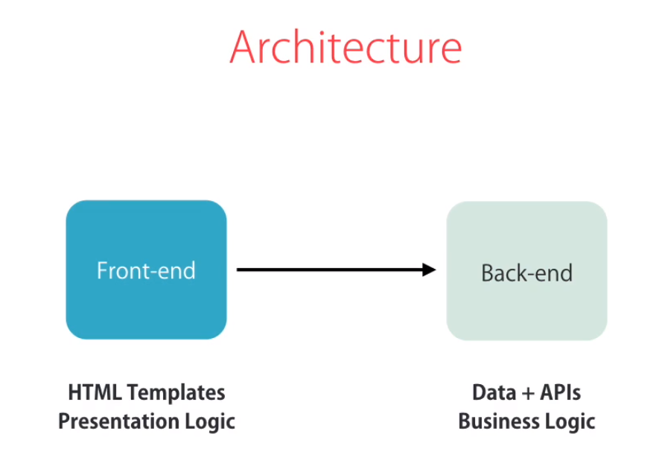

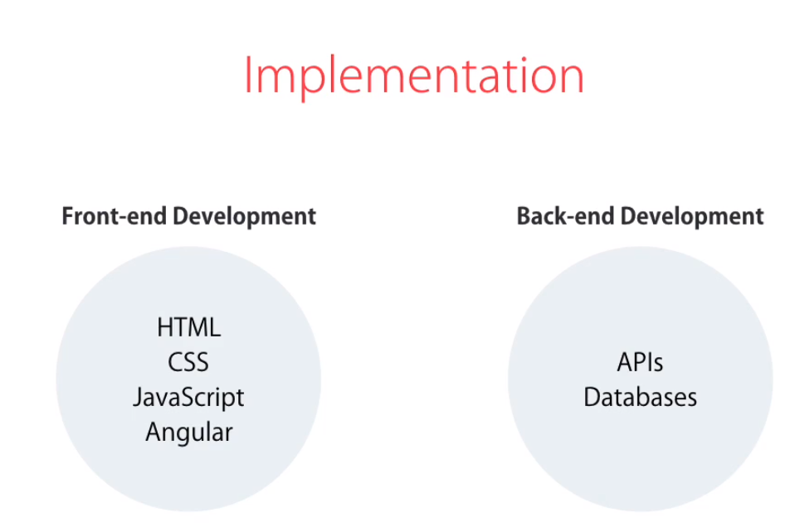

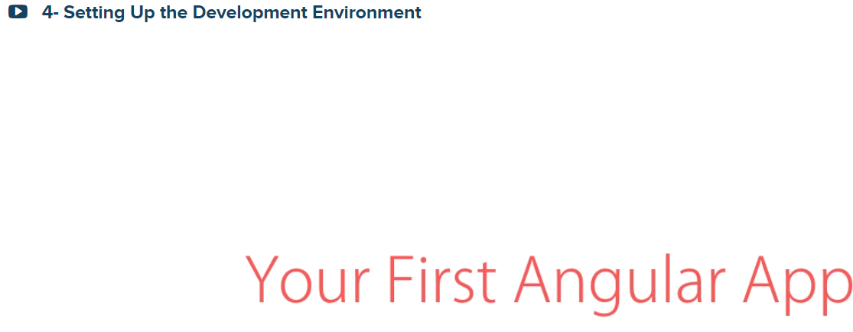

1. Install Node
2. Install Angular CLI (Command Line Interface)



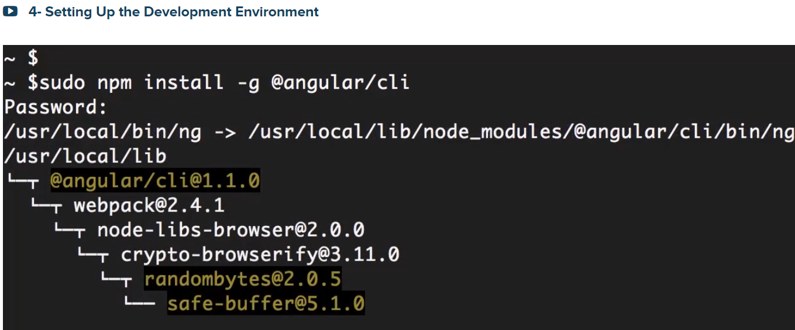

ng –version

create a new Angular project:

**ng new hello-world 🡪creates a new workspace and an initial Angular app**

**to use the light weight vscode editor, from windows**

**Press Shift/Control, the P (palate), type >code then select Install ‘code’ command in PATH**

**The from the DOS type code . (to open it in vss code)**

**To load our application type**

**ng serve 🡪 builds and serves your app, rebuilding on file changes**



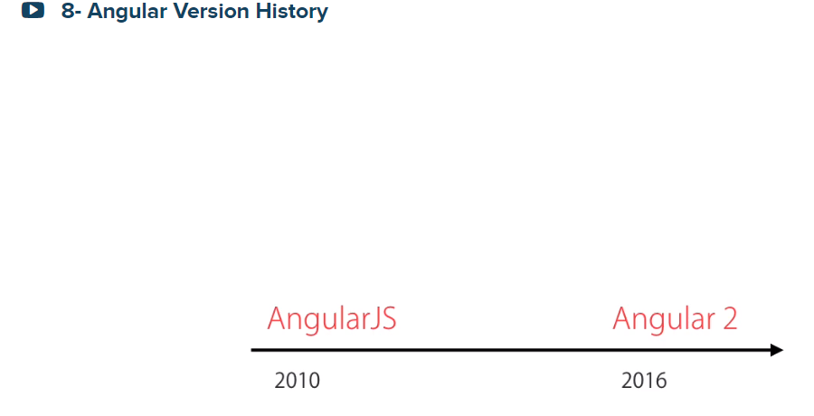

Then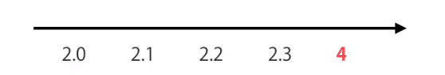

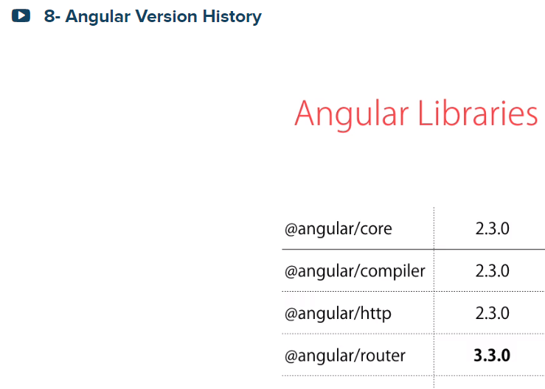

So, I am either AngularJs(1.x) developer or Angular (2, or 4, or 5, or 6) developer

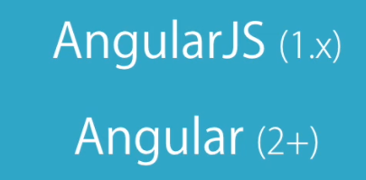



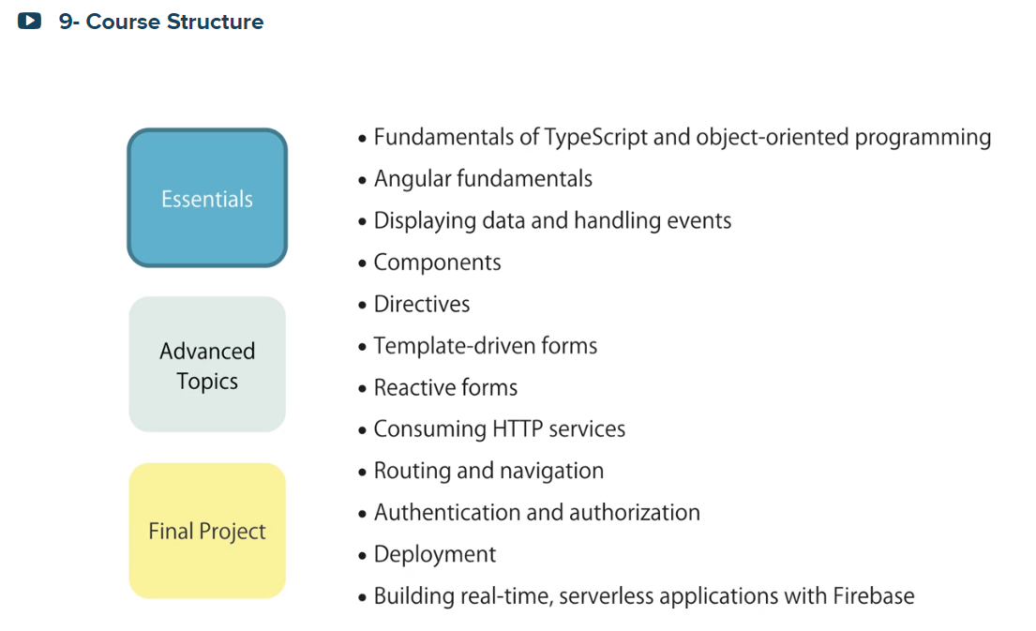

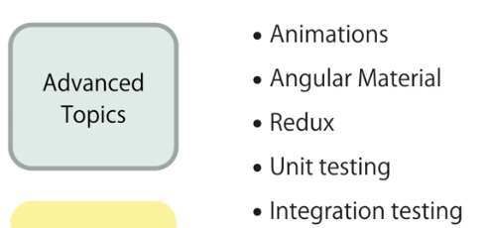



Introduction:



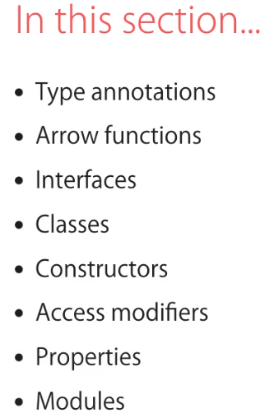

What is Type Script?

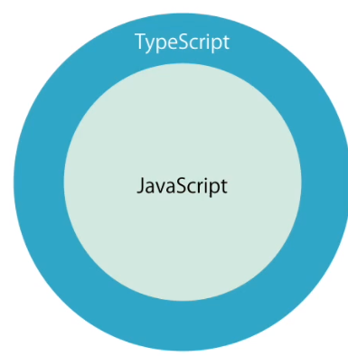

Type Script has a strong/static typing. Also good for great tooling(intelecense)

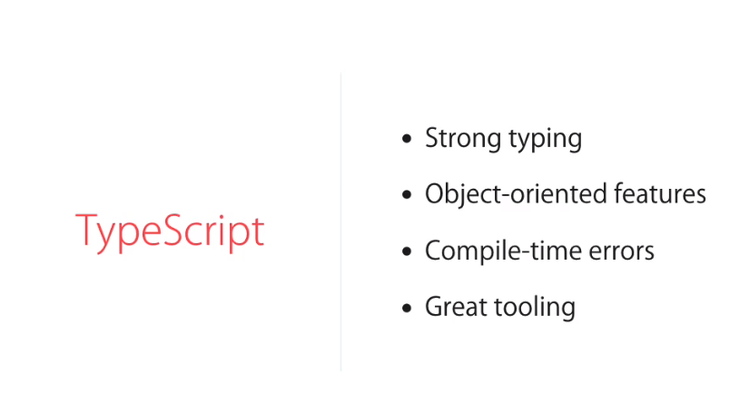

Type Script to transpiled/compiled to Javascript so the browsers can understand it,

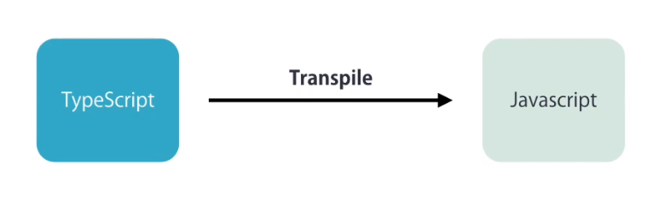

install -g typescript

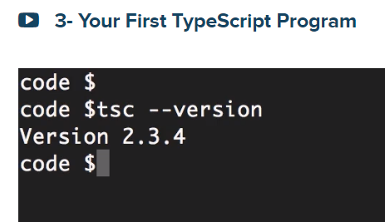

C:\2019\ts-hello>code main.ts

C:\2019\ts-hello>node main.js

Hello world!

After ES5, Type Script goes by Year like ES6 (2015) …

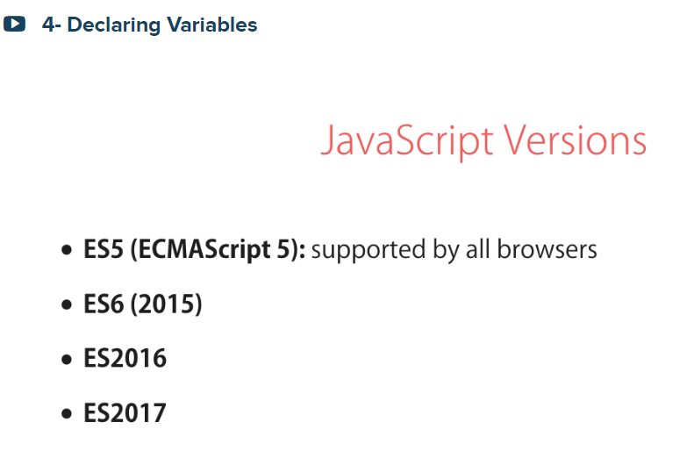

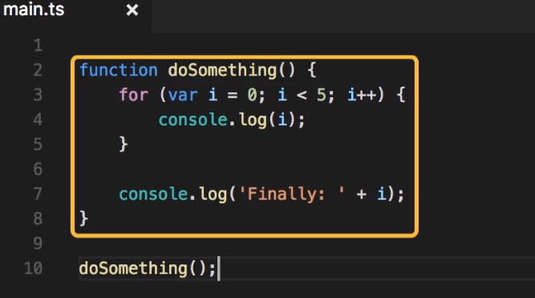

The value of i = 5 due to var i

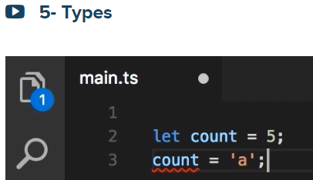

Early compile error

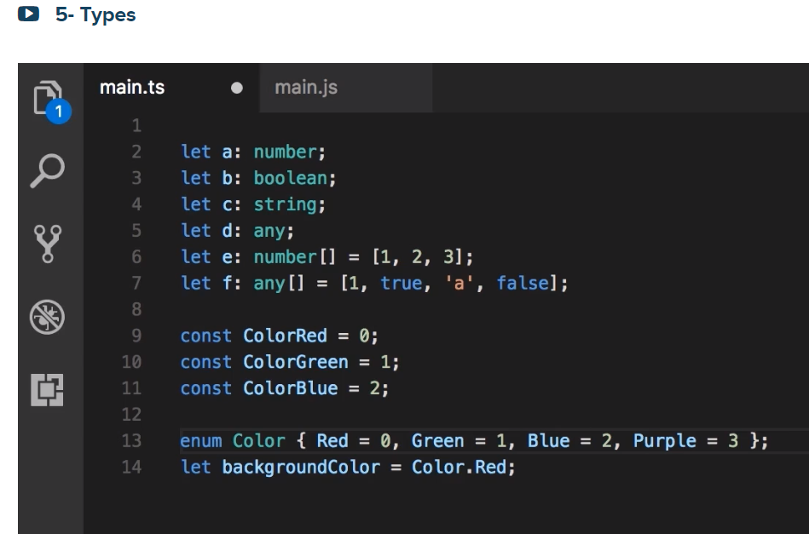

Let us see what we got after we compiled the above types: tsc main.ts

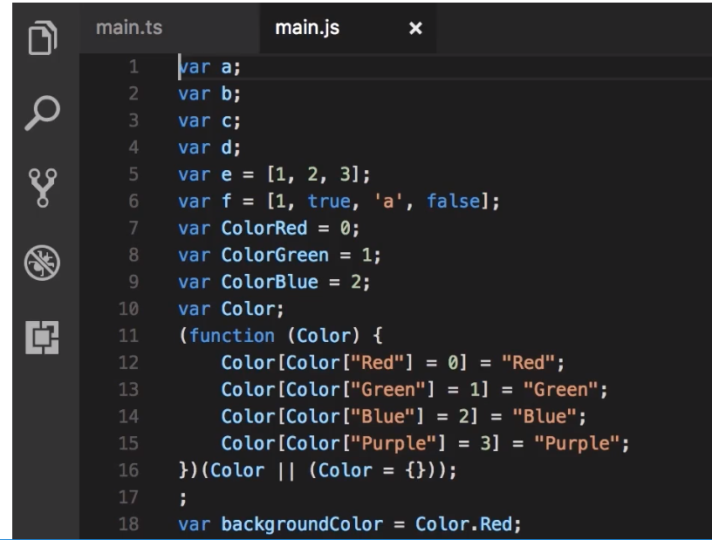

Let us look at the Typescript tool tip for string:

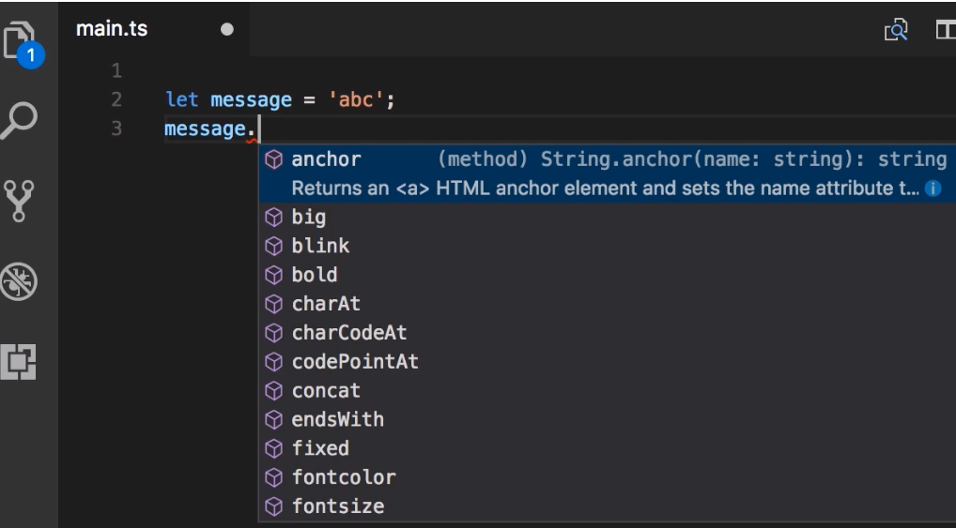

let message – alone it is an any type. So to convert it to a string type do the following

Let us show type assertion: by (<string>message).anymethodName(..)

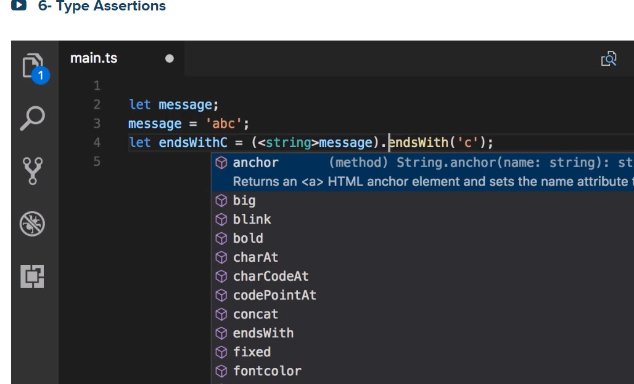

Or you can do it in this way too:

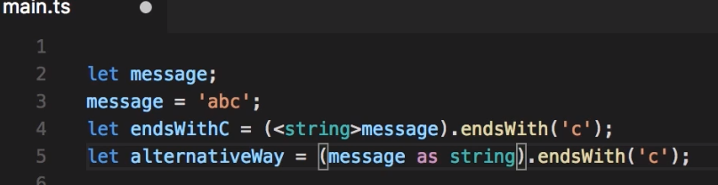

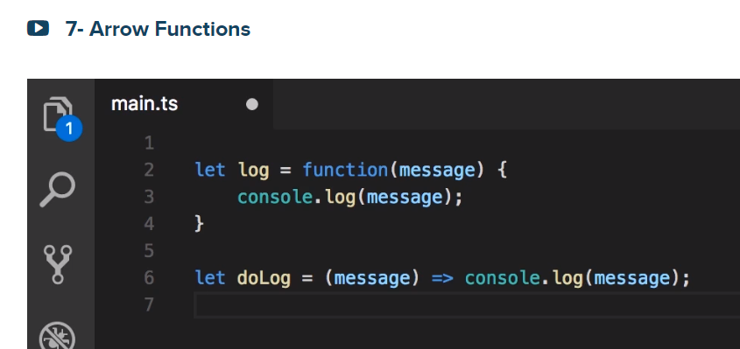

The following is exactly the same with c# Lamda expression

let doLog2 = (message) => console.log(message);

Now let us see a custom type in TS

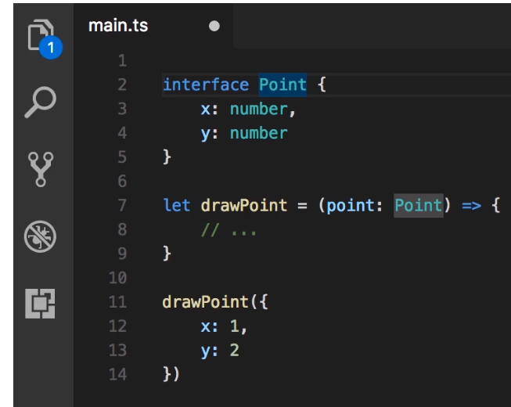

Things that go together are called cohesion

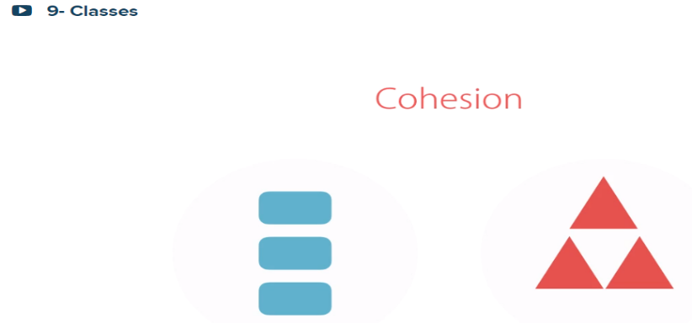

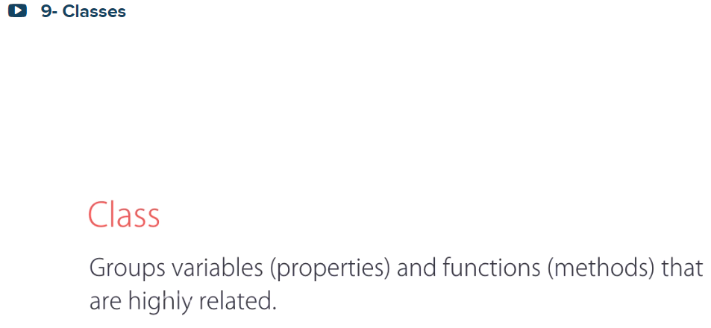

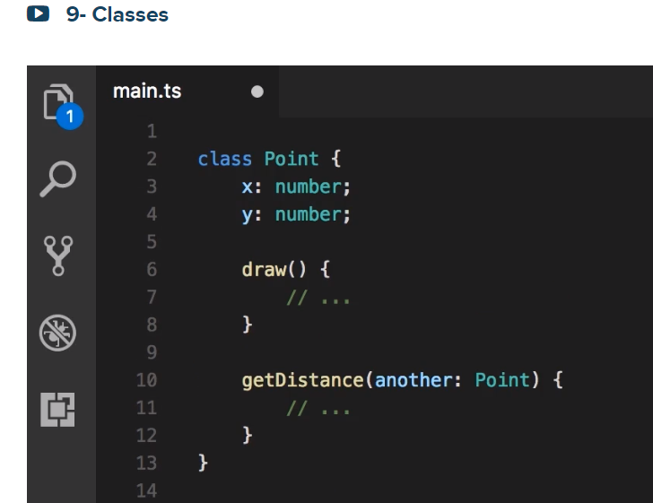

This is correct one:

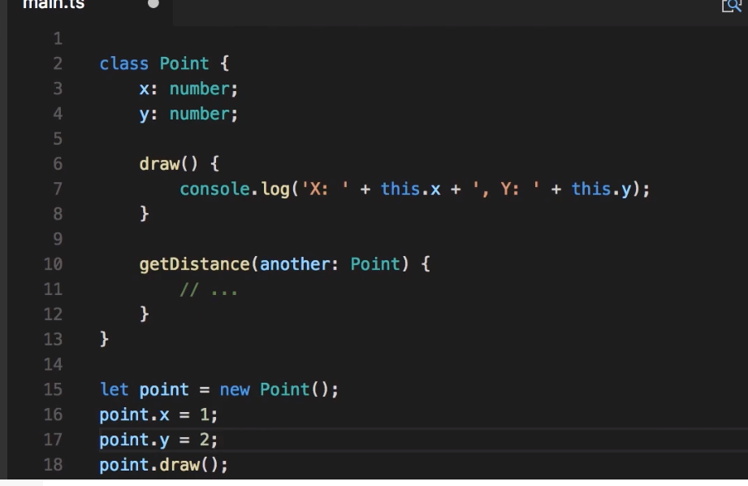

By adding ? to the parameter of the constructor like x? and y?, you can make optional.

That is you can pass args or not

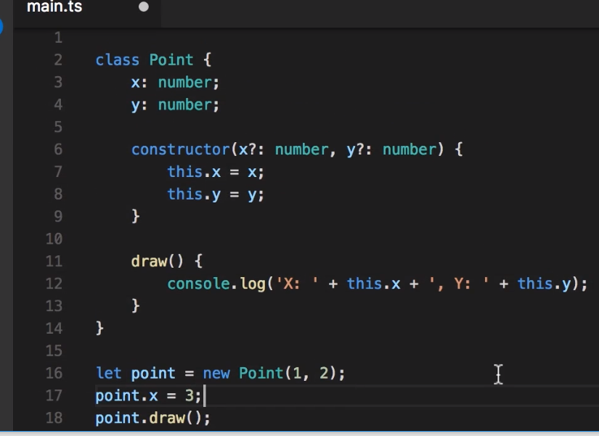

Use Access modifiers to control point.x = ??

By default all members in ts are public

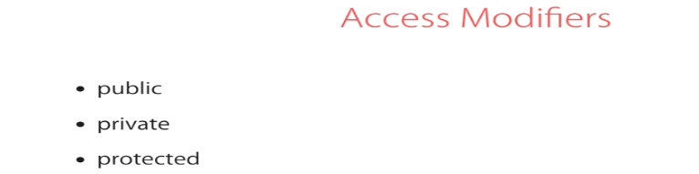

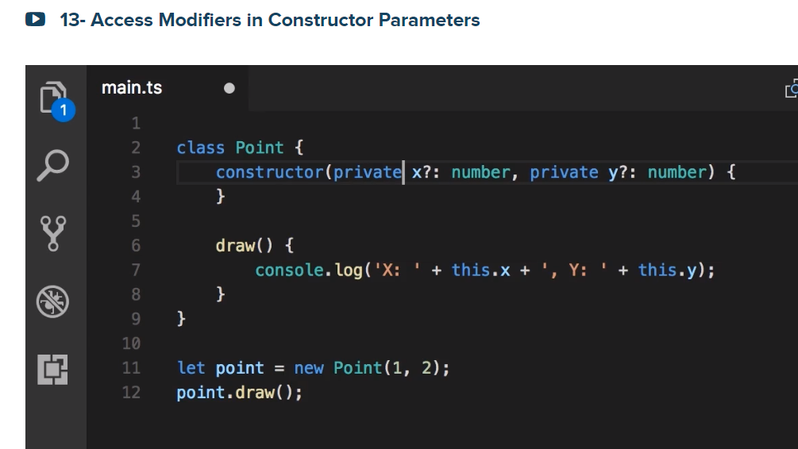

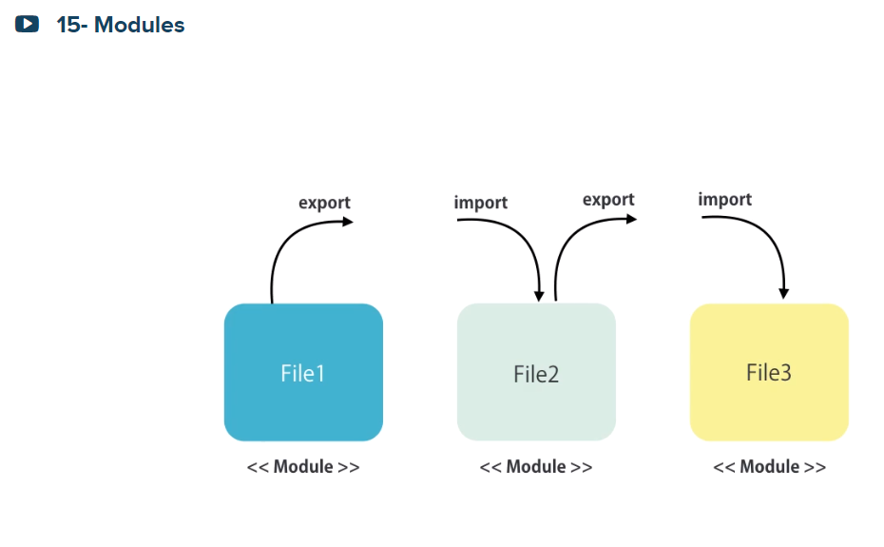

**16- Exercise**

Imagine you're working at Facebook and your job is to implement the "Like" functionality.

When a user clicks the "Like" button below a post, the button is highlighted (to indicate that it is selected) and the number of likes is increased.

You're going to implement this feature in Angular and for that you'll need to create a component. This component is a TypeScript class that encapsulates the data for rendering the like button (eg: the number of likes, and whether the button is in the on/off state). It also responds to user actions. So, when the user clicks the "Like" button, the number of likes should be increased and the button should be in the "selected/on" state. If the user clicks the button again, the number of likes should be decreased and the button should be in the "unselected" state.

**Spec**

For the purpose of this exercise, forget about the HTML. Your focus should be purely on defining a TypeScript class with the right members (fields, properties, methods, constructor).

Allow the consumer of this class to pass the initial number of likes when creating an instance of this class.

Define this class in a separate module and use it in the main module. Simulate the scenario where the user clicks the like component. Display the total number of likes and whether the button is in the selected or unselected state on the console.

How to compile and target for ECMA SCRIPTT HIGHER:

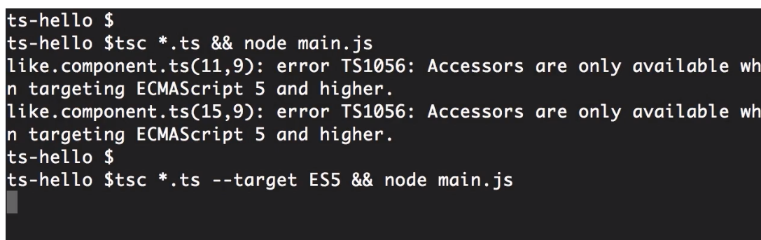

Or

C:\2019\ts-hello>tsc main.ts --target ES5 && node main.js

likesCount: 9, isSelected: false



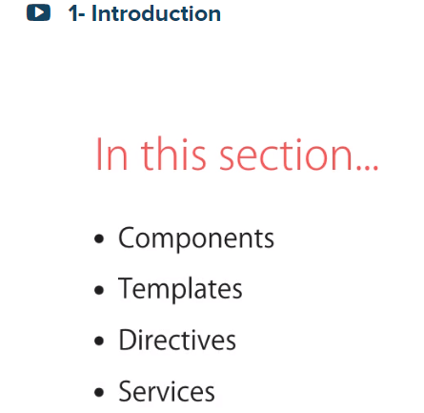

Let us start now

Building Blocks of Angular App

What is a component? A Component encapsulates data, HTML Template and Logic (an area for a view)

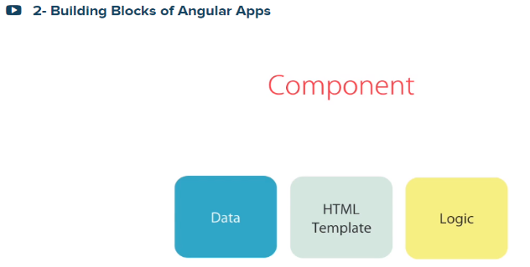

Let us look at a Udemy site:

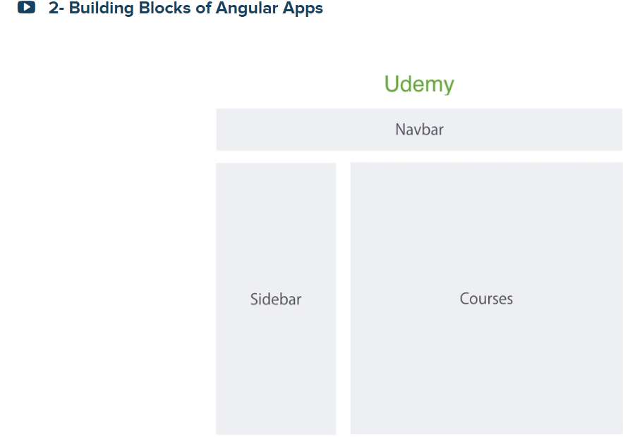

So we can see this as one view or component as indicated below:

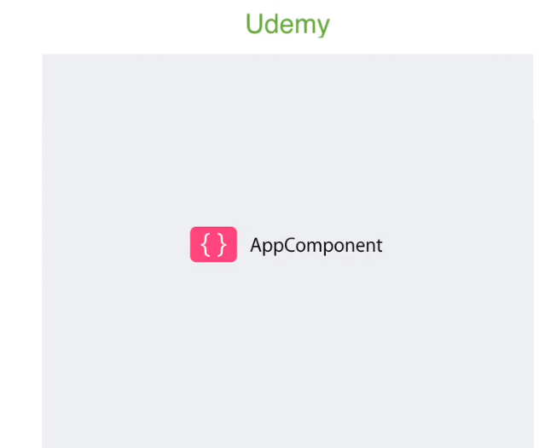

Or we can break them into smaller and maintainable component as indicated below:

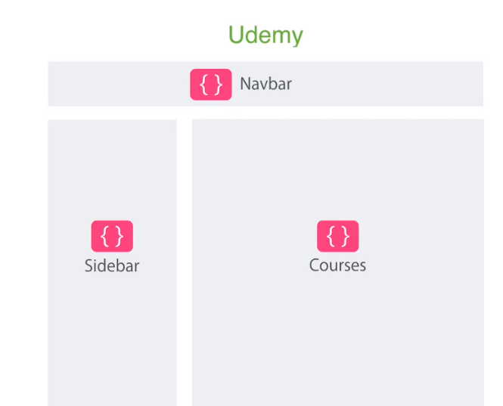

And then break courses into smaller components:

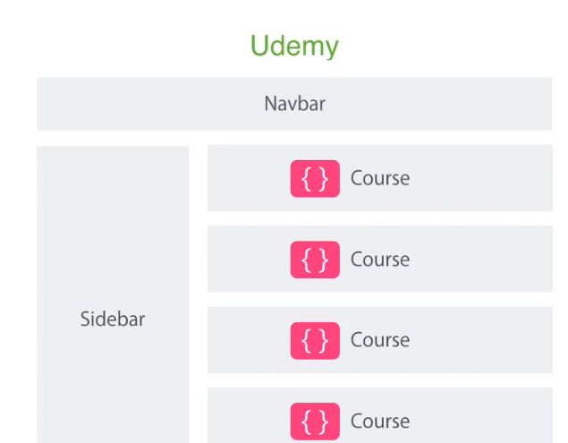

And also into:

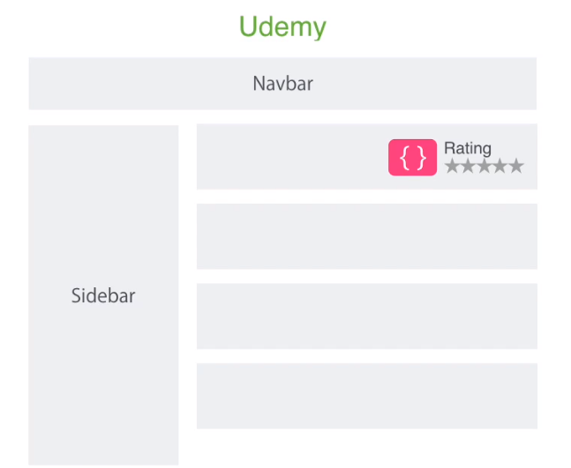

Every app has a root component or a Root component

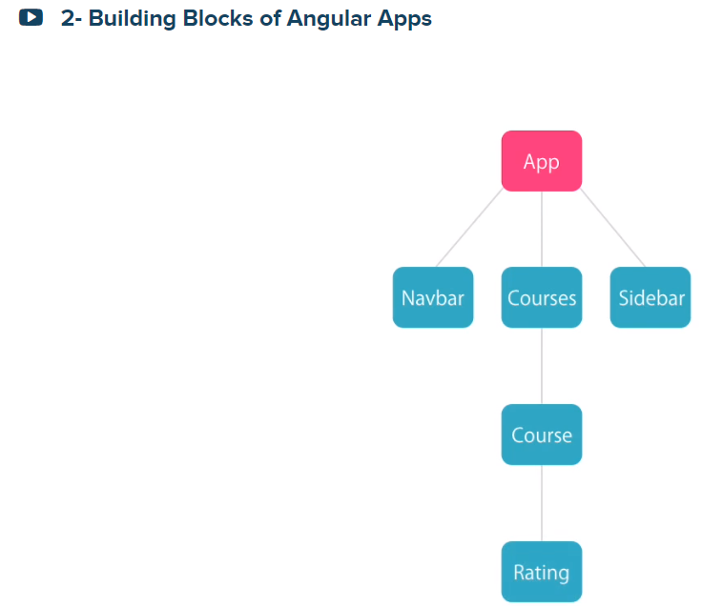

There is another concept called Module in Angular. A module is a container for a group of related components. Every Angular app has at least one module called an App Module

For instance, here are a sample of Udemy modules:

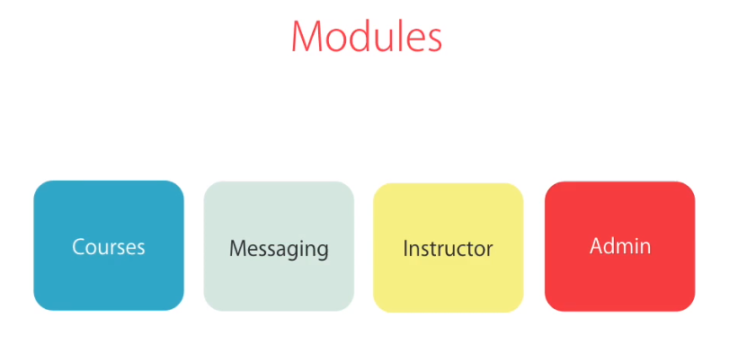

Look at real world supermarket Io module



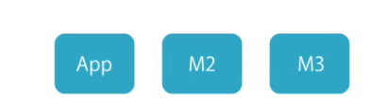



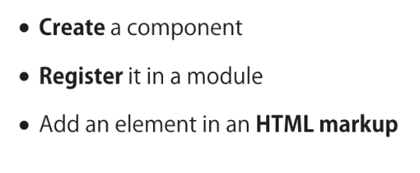

How to use selectors based on css selector

For instance, the selector for //<courses> “courses”:

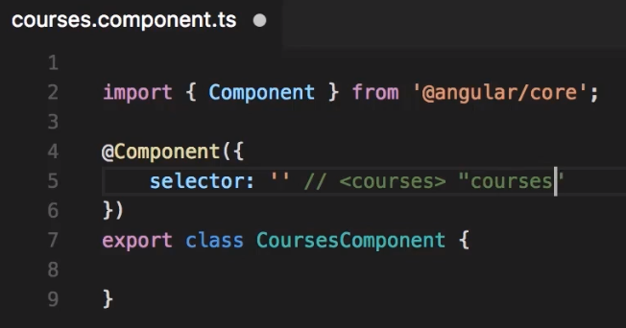

the selector for //<div class =”courses”> “.courses”

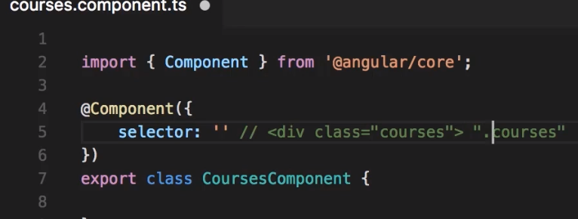

And so on

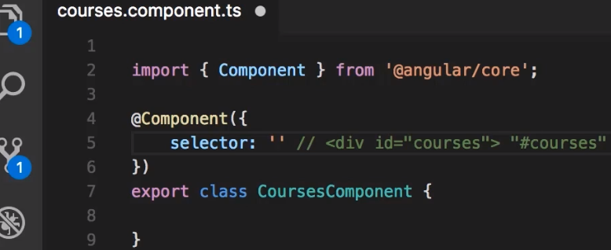

To add ‘auto import’ plugin to vs-code, click on left-side bottom square, and type ‘auto import’ on the top search Extensions as shown below:

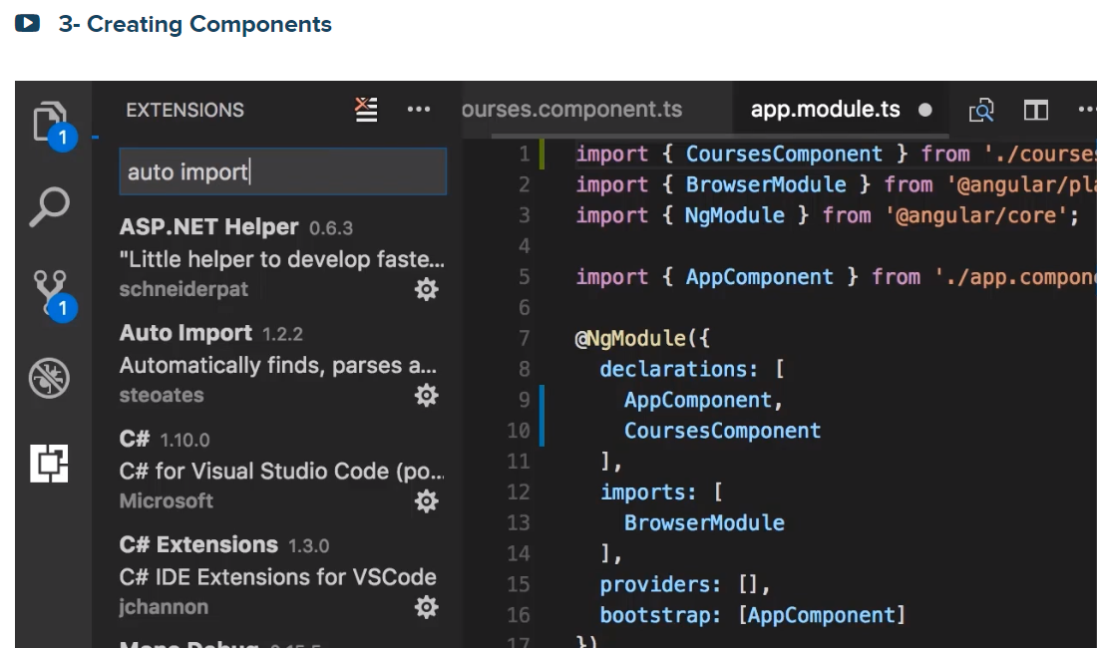

ng generate component course

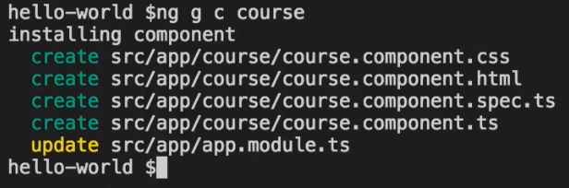

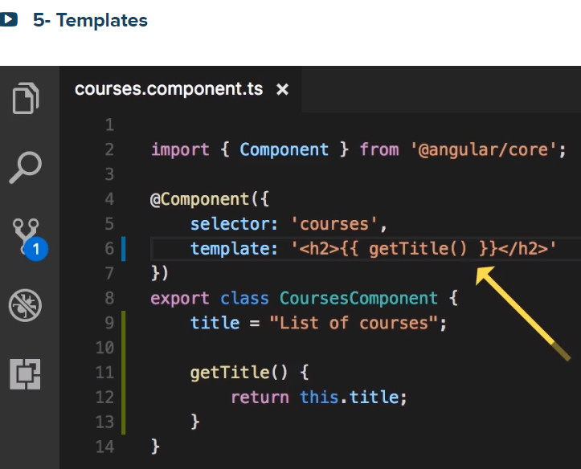

The above arrow points to the syntax that is called string Interpolation

Again, What is a component? A Component encapsulates data, HTML Template and Logic (an area for a view)

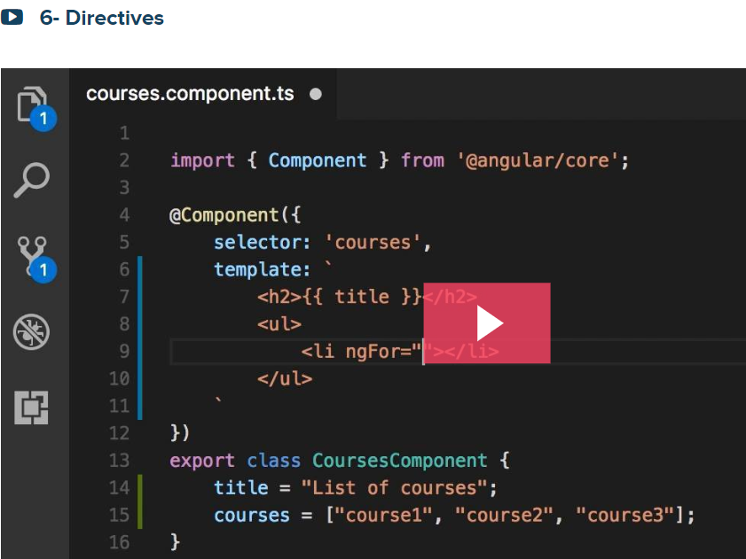

We use Directives to manipulate the DOM: to add/remove elements, change the class of a DOM or element or its style

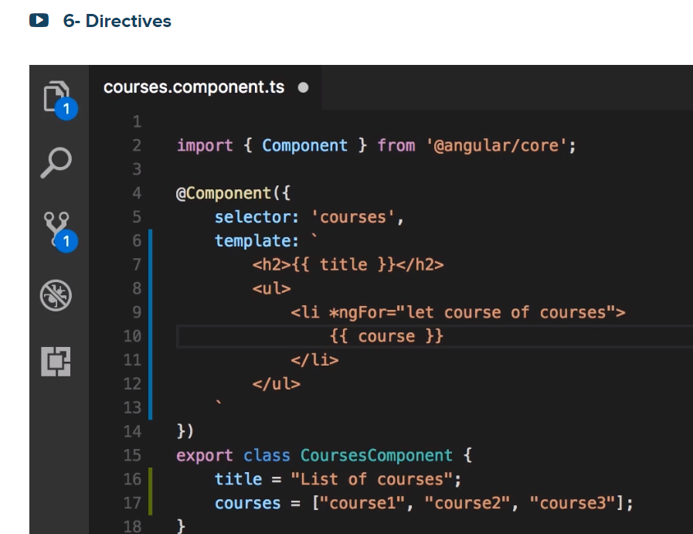

Let us get list of courses from a service by creating a fake service:

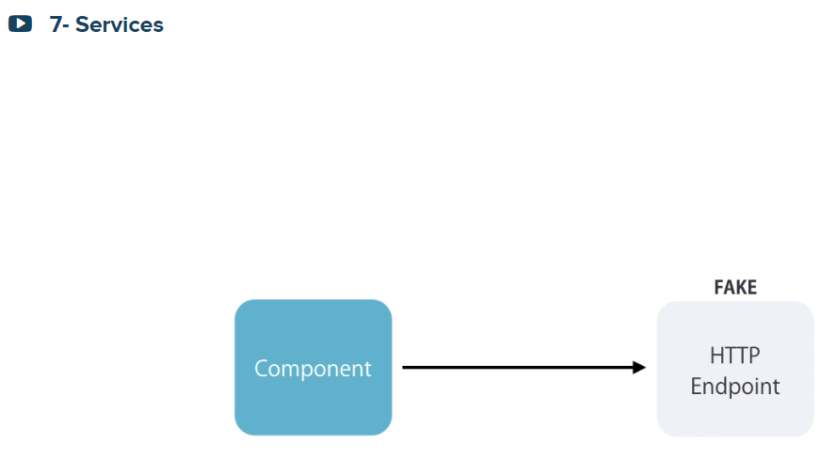

The next one is tightly coupled the service with the component

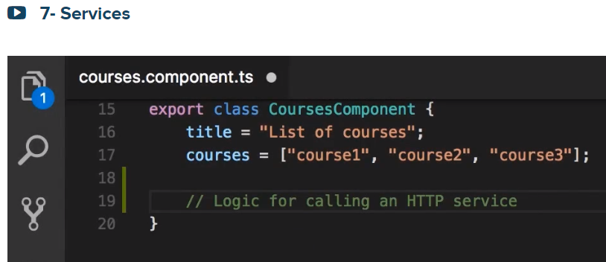

A component should have any logic other than the presentation logic. So, the above scenario is bad design

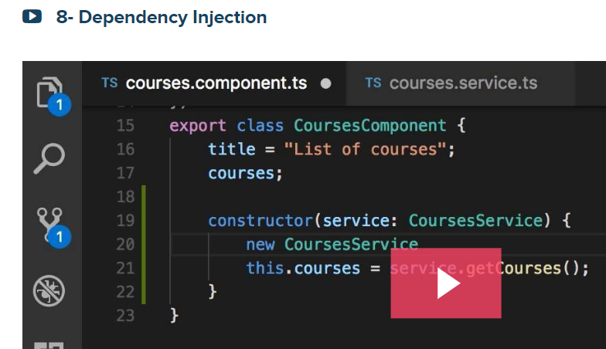

We should instruct angular to inject/proivide the CoursesService to its constructor. This is called DI

Injecting the dependency of a class into its constructor.

That means, the CoursesComponent class depends on the CourseService, so you provide/inject CoursesService to the CoursesComponent ’s constructor

You add it

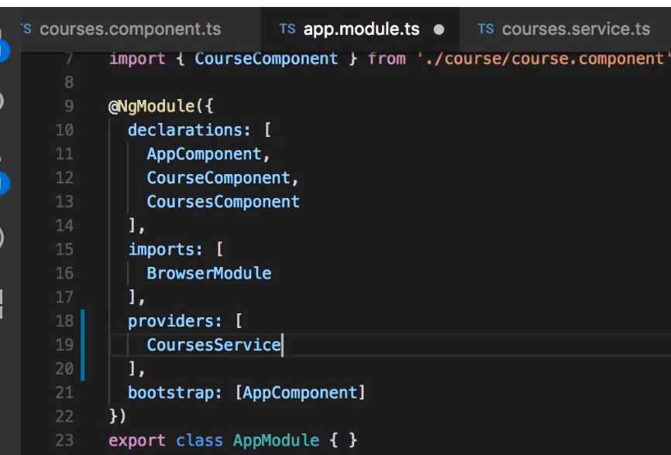

When you register a dependency as a provider in a module, Angular will create a singe instance of that class for that entire module

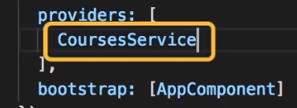

This is what we call the Singleton pattern:



A single instance of that object exists in a memory….

ng g s email 🡪 ng generate service email

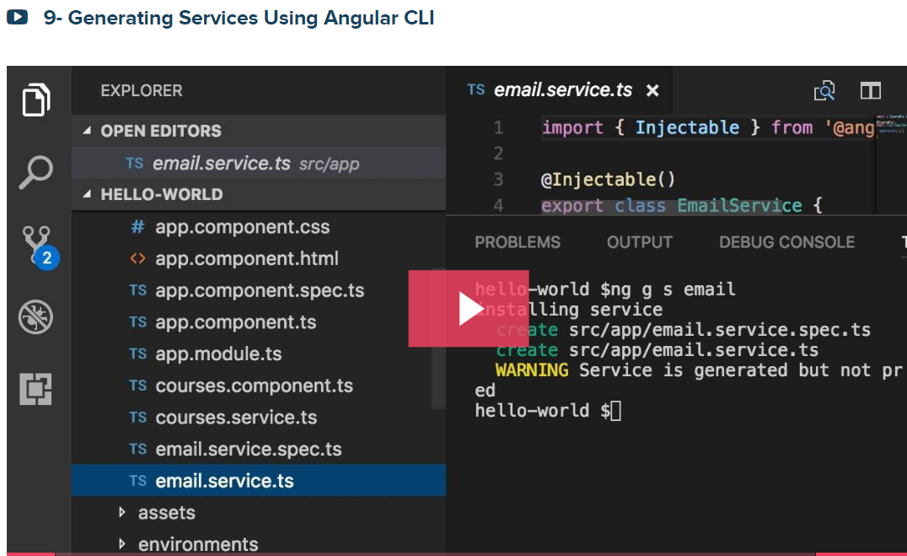

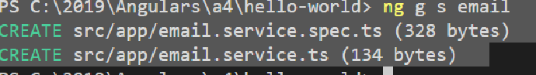

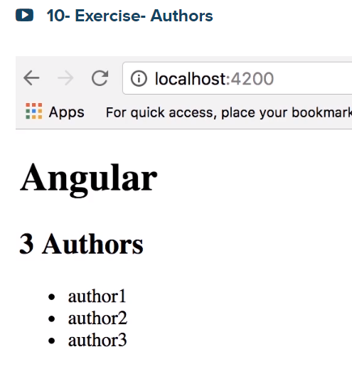

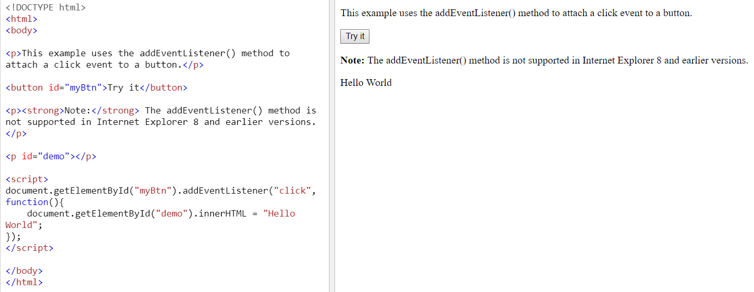

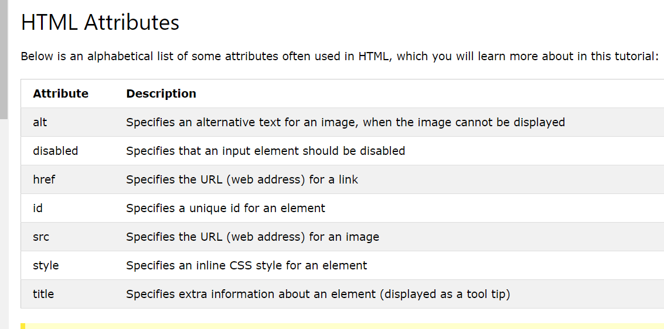

How to auto generate

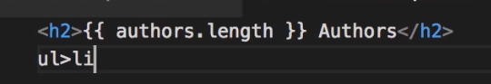

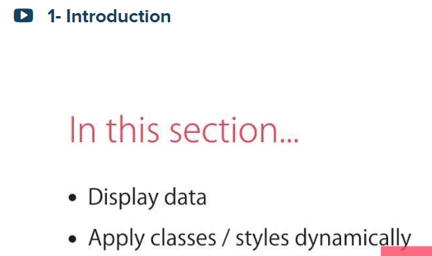

Displaying Data and Handling Events

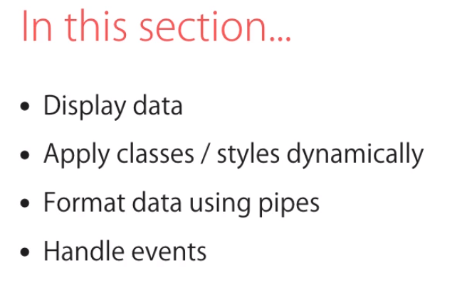

Property Binding

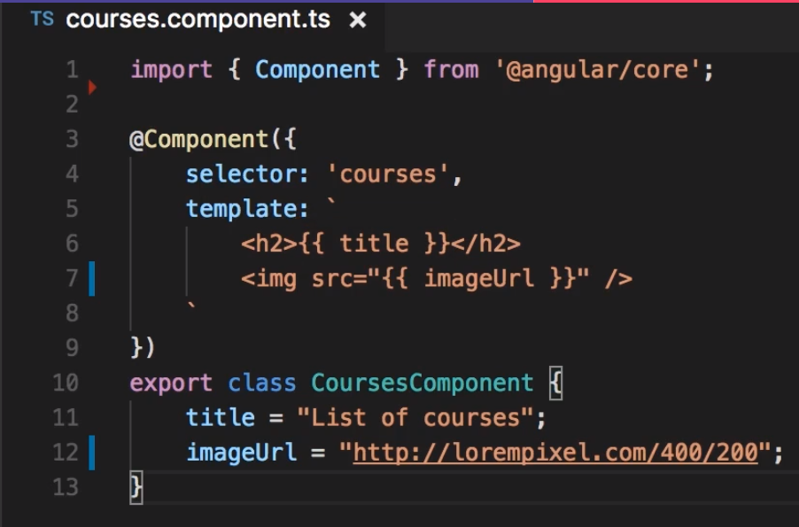

With the above we get something like this:

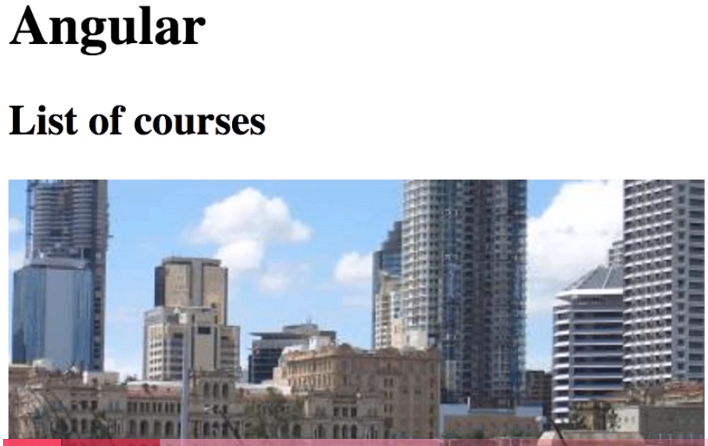

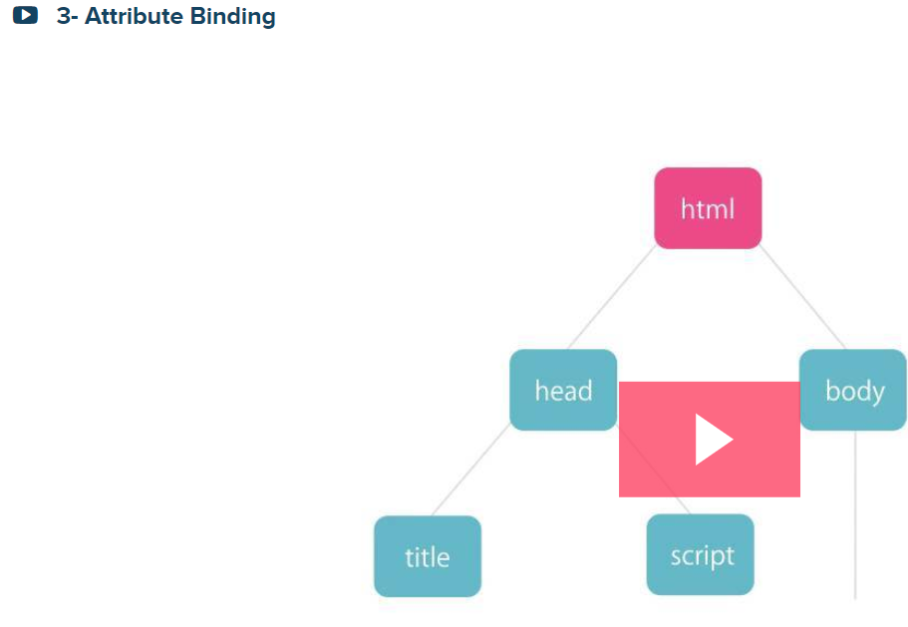

First let us see a property binding

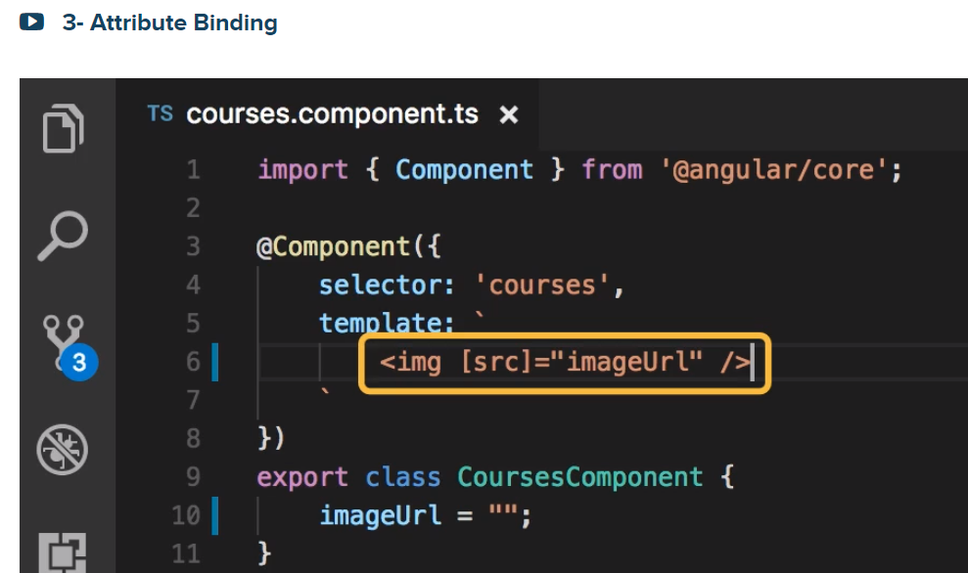

Let add another property as shown below:

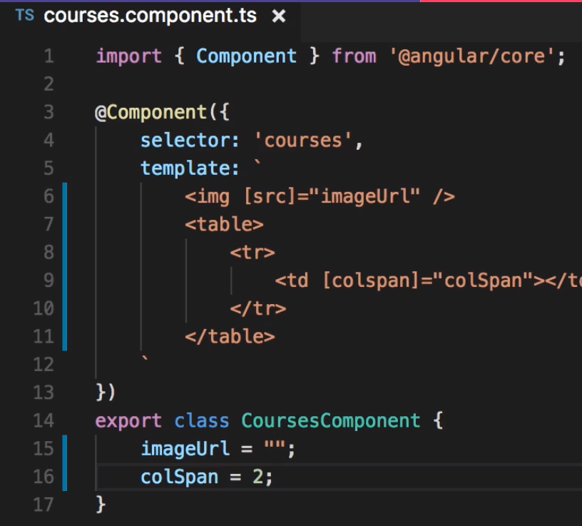

Display was blank due to the following:

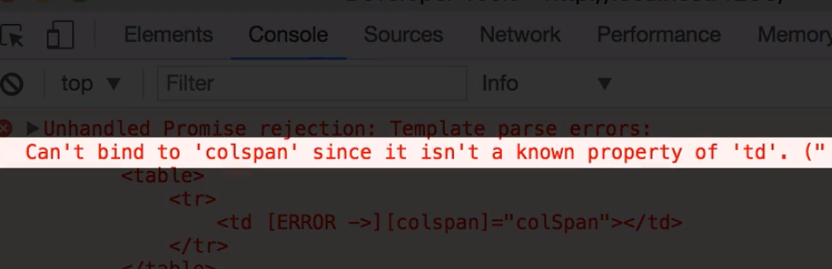

To understand this error, first you need to know:

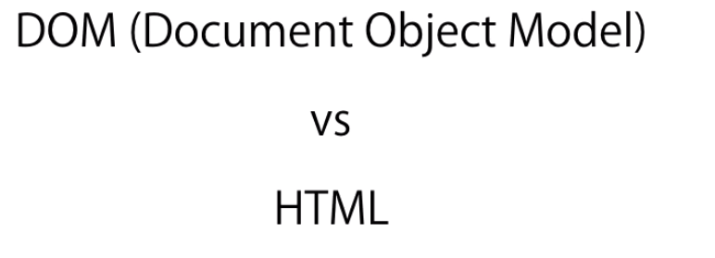

What is DOM? Dom is a model of objects that represents the structure of a document. It is a tree of objects in memory

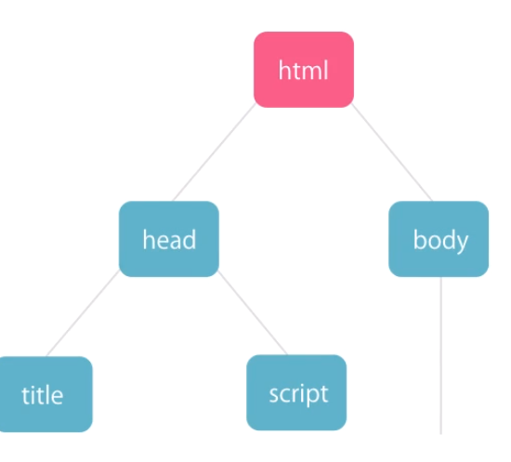

HTML is a markup language that use to represent DOM in Text.

When your browser parses an HTML document, it creates a tree of objects in memory that referred to as DOM. We can also create the tree of objects using javascript programmatically.

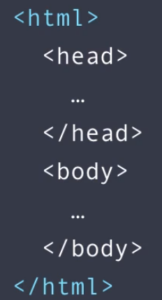

Here is a 1-1 mapping

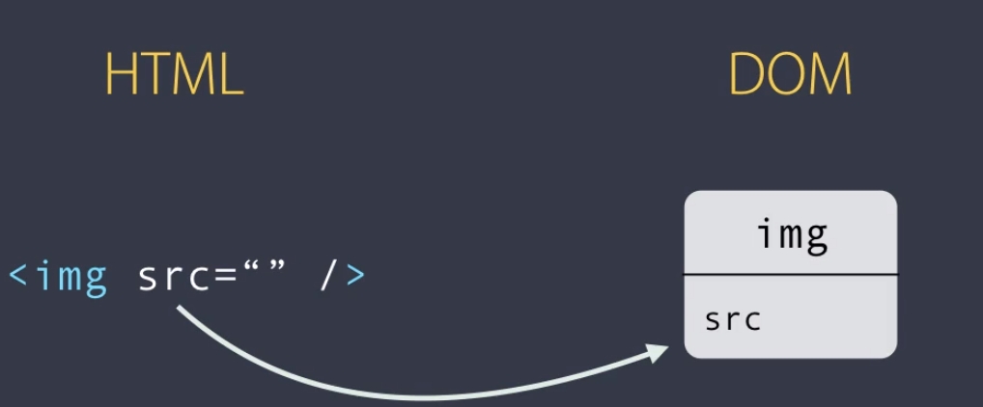

To Fix it do

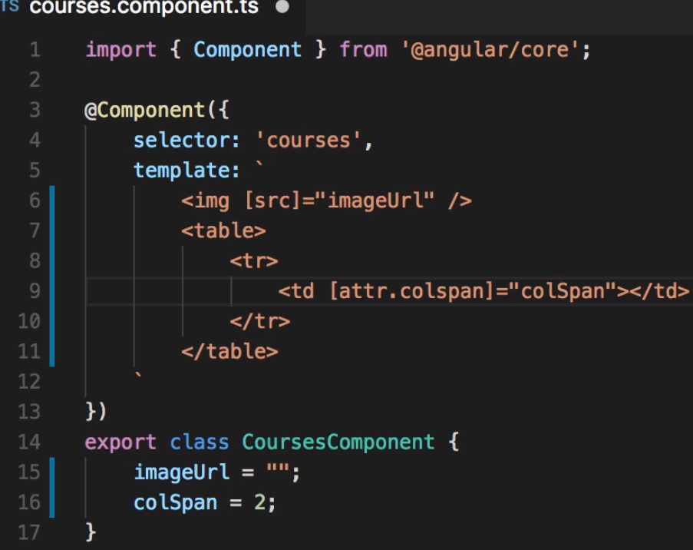

Adding Bootstrap – it is a CSS library that gives your app a modern look

Getbootstrap.com

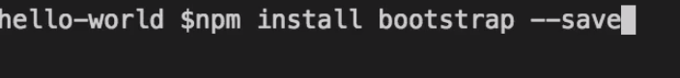

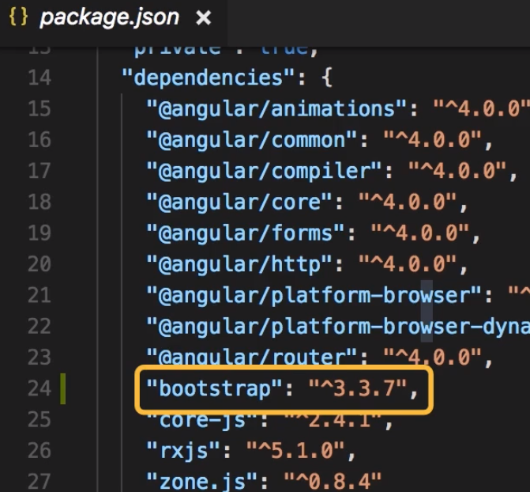

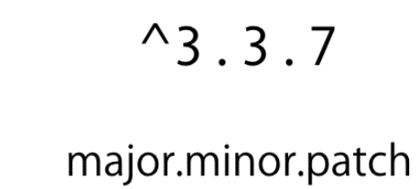

Import bootstrap (~) related from node_module’s folder

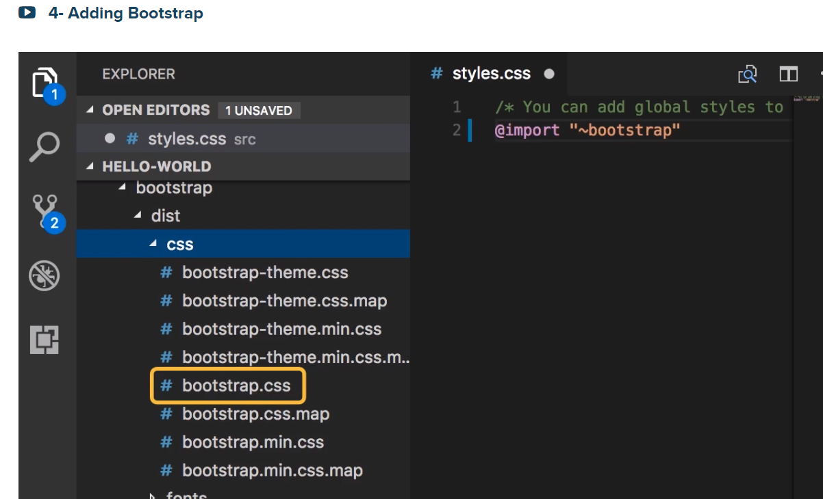

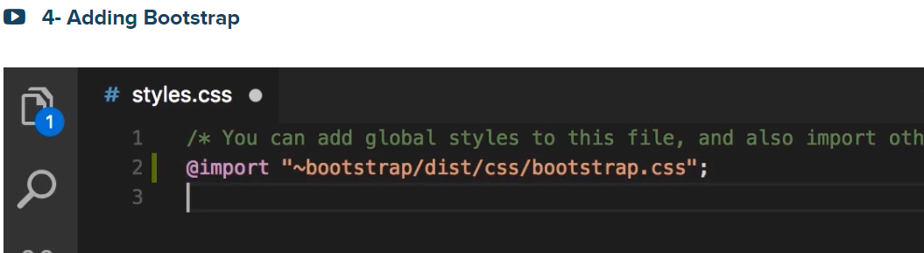

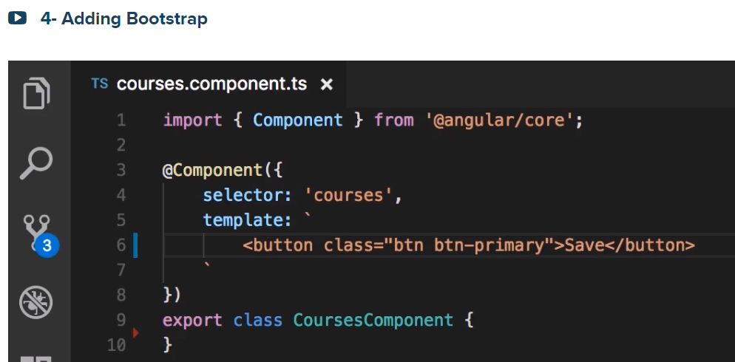

Produces 🡪 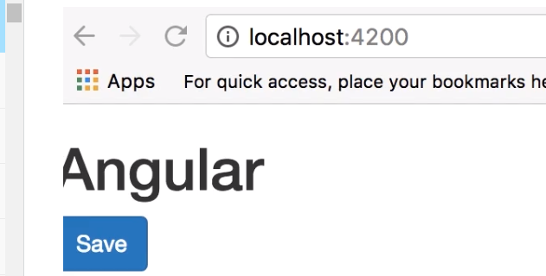

Add padding:20px to move the button 20px to the right

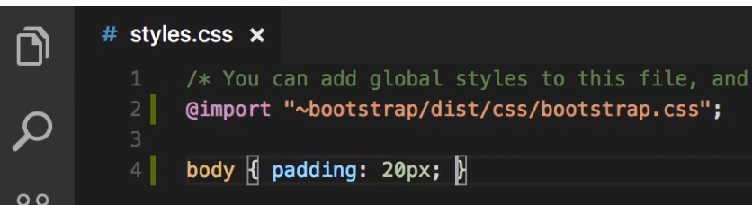

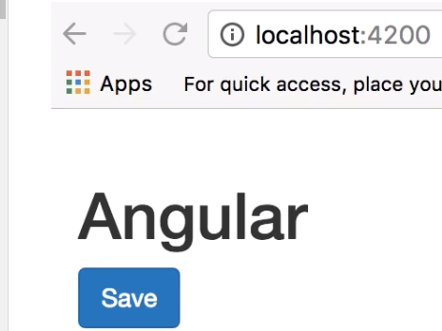



I put the above without 20px from comparison purposes

**Class Binding**

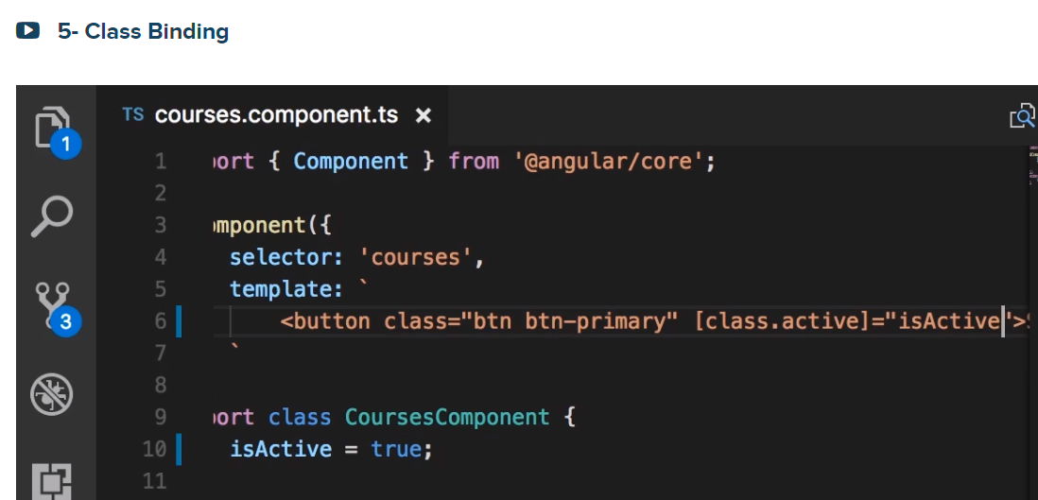

**🡪[] is the property binding syntax as indicated in [class.active]=”isActive”. Note class is the propery here, and we specify the name of the target class .active**

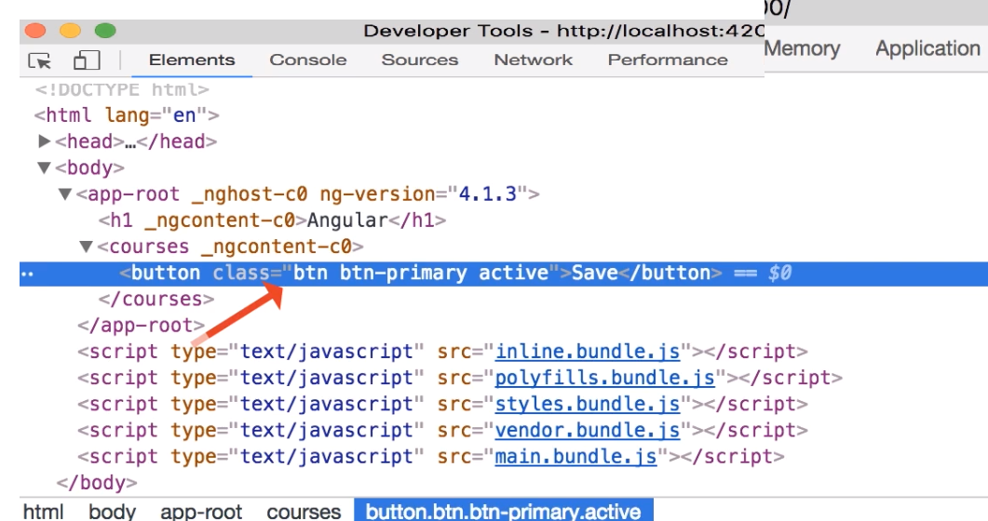

If you assign the isActive = false then we get the following:

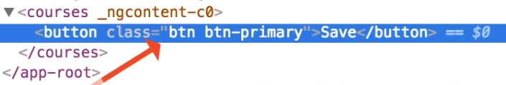

You see the active class is gone

Now let us see Style Binding- search for “dom style object properties”

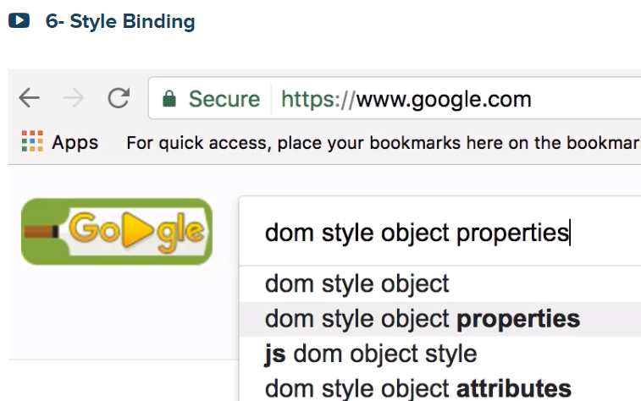

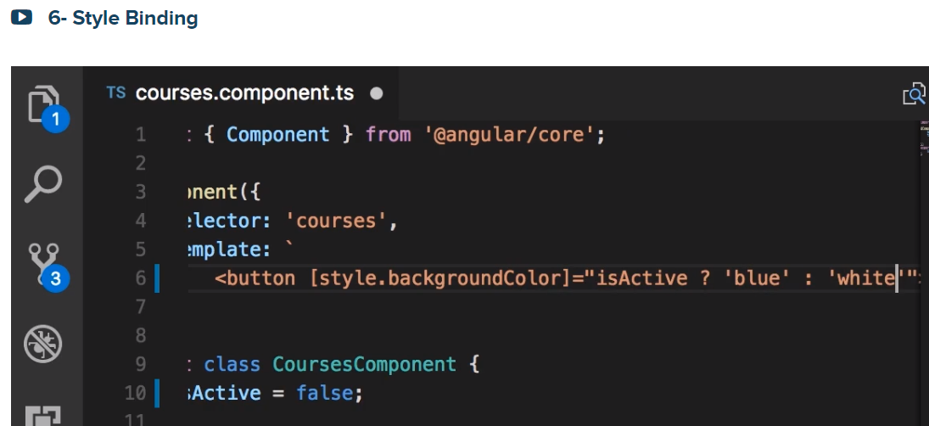

Event Binding

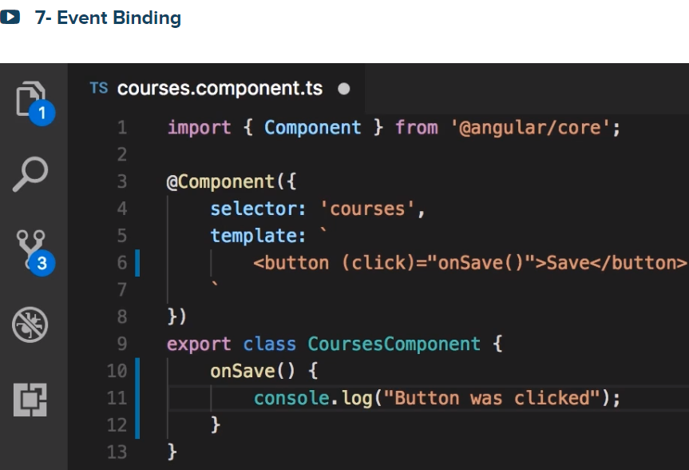

The name of the Event is (click) and bind this to a method on the component (CourseComponent)

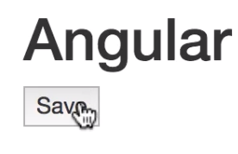 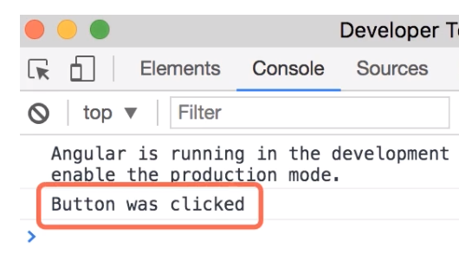

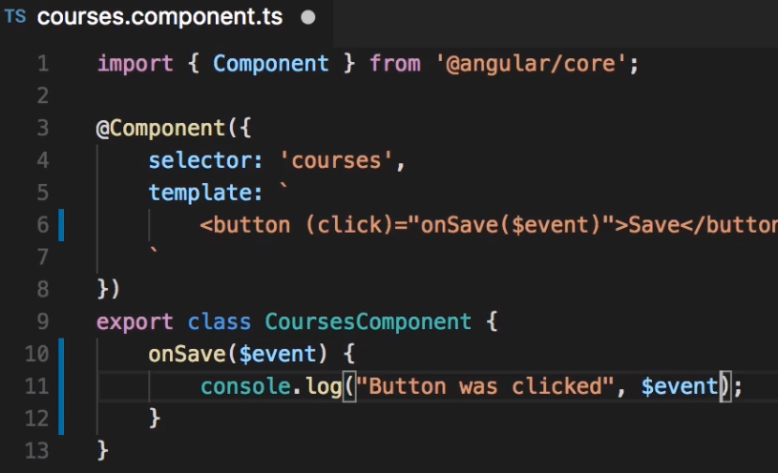



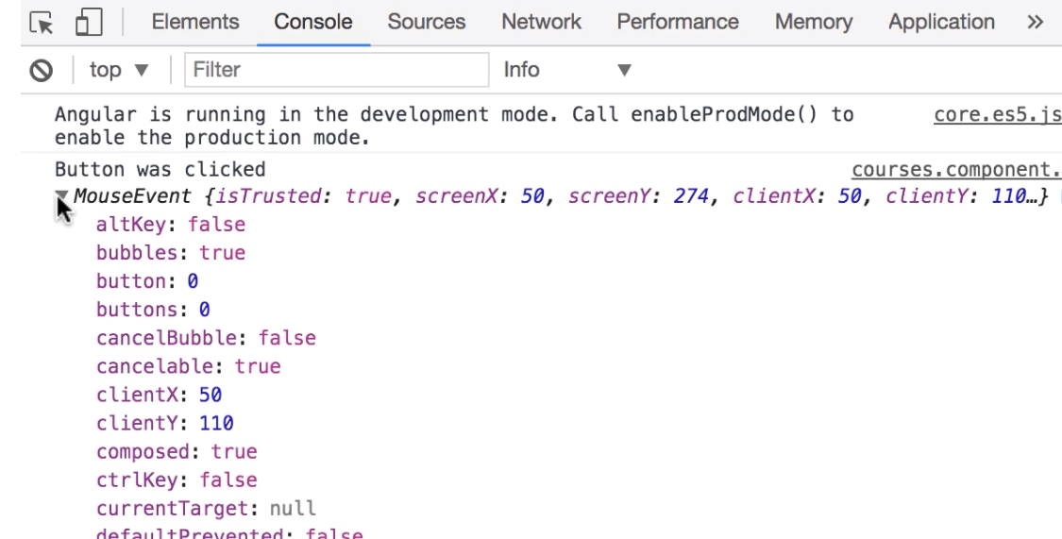

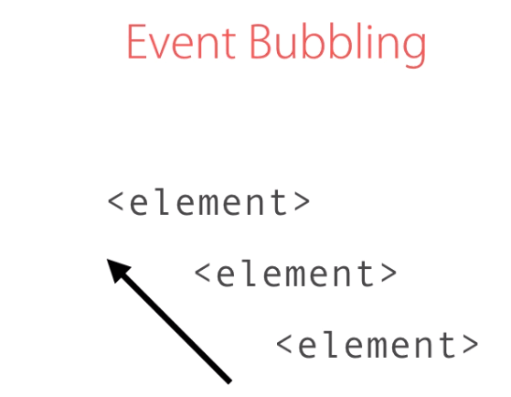

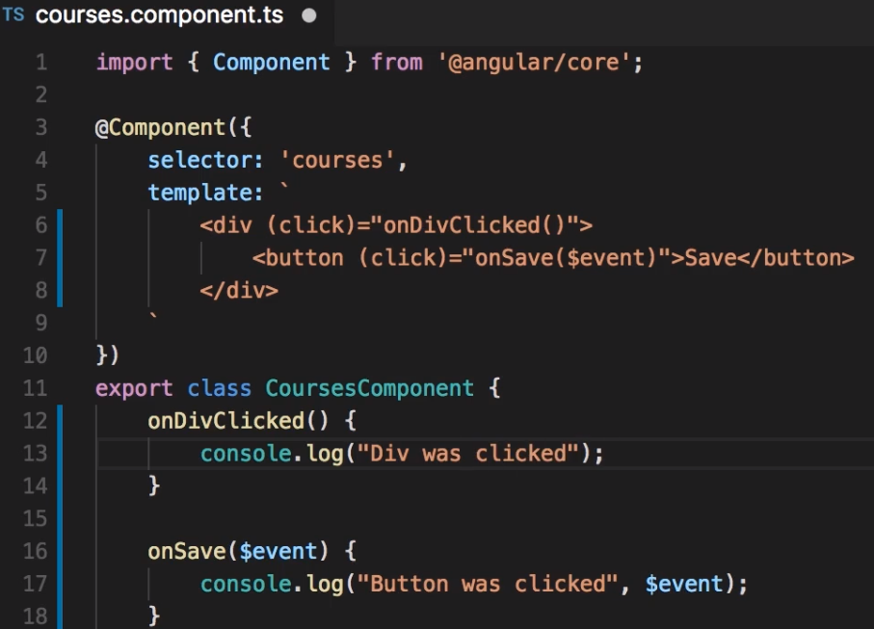



Then you see below

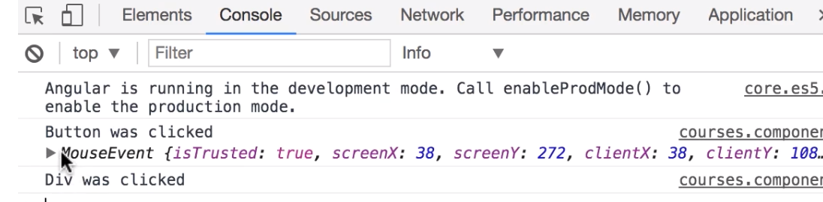

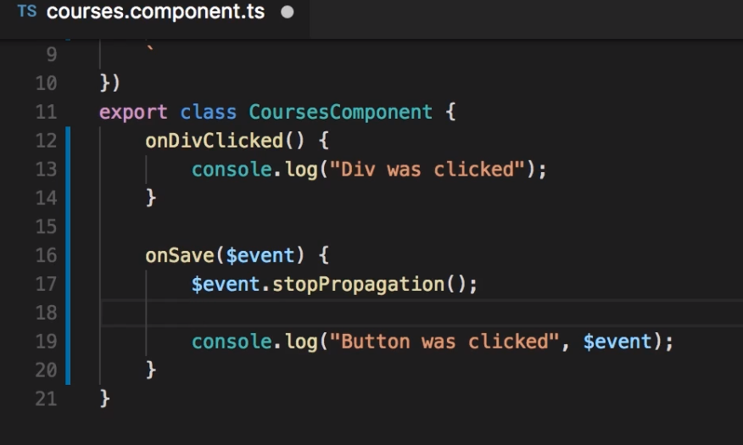

**Now, it will not propagate, that means you will not see the “Div was clicked” event**



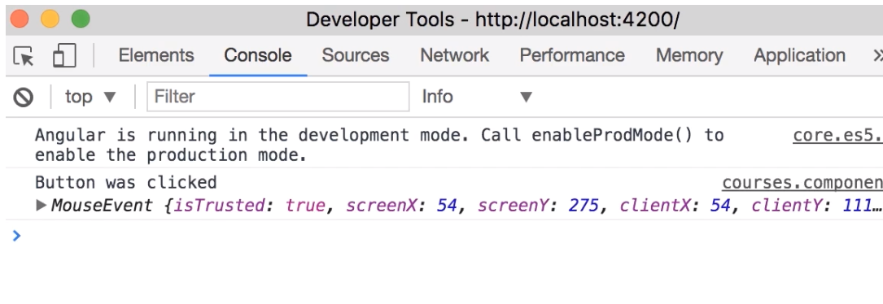

**Next Event Filtering**

**old way. (if $event.keyCode===3) // 13 is Enters**

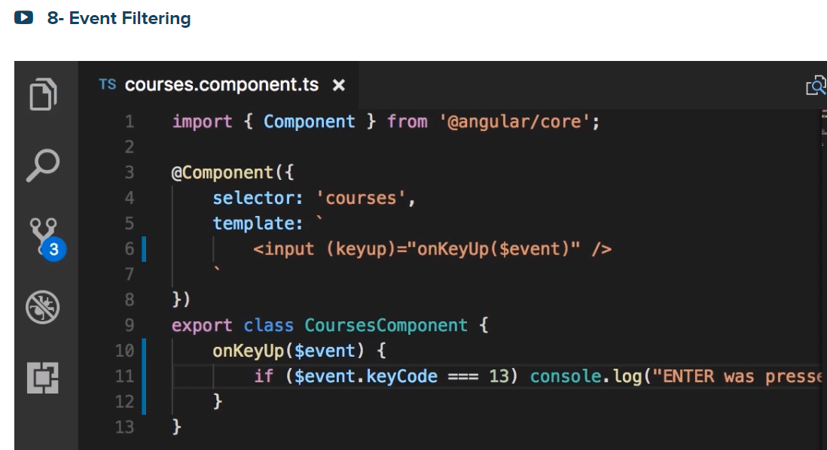

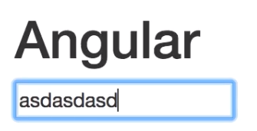

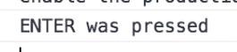

With Angular, here is a much cleaner way:

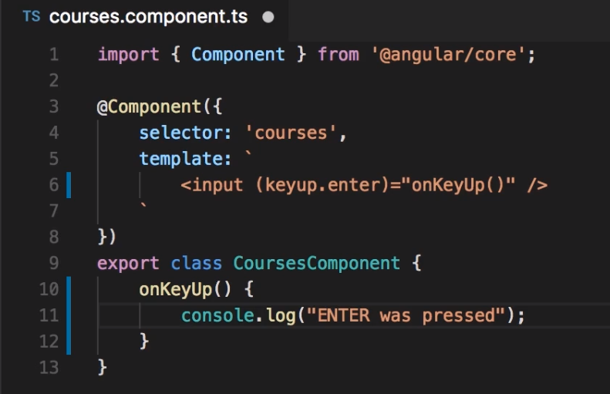

Template Variables.

How do you get the value that was typed in the input field? There are 2 ways.

One way is using the $event object🡪 and it has a target property that references this input field, and from there you can get the value 🡪 $event.target.value as indicated below:

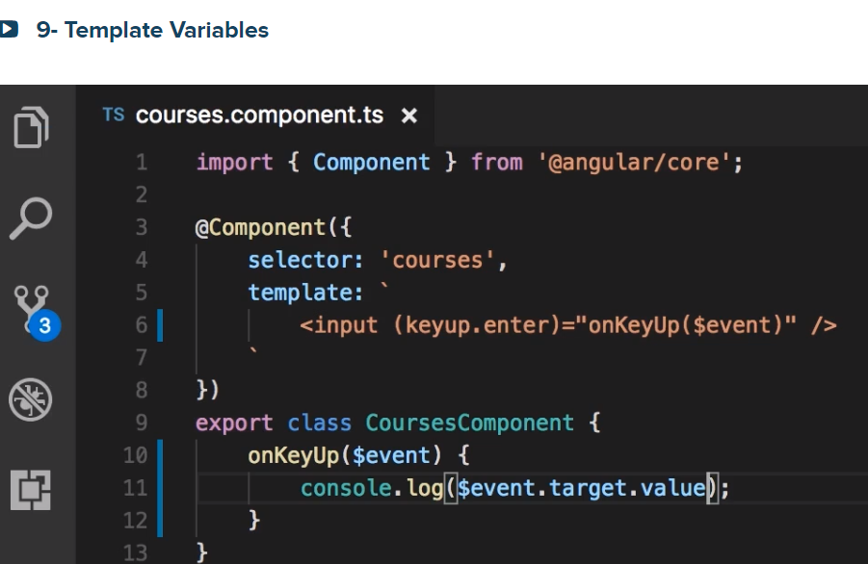

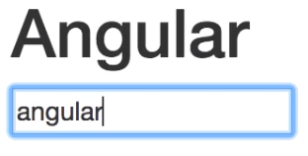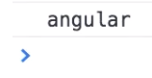

Or you can pass a tamplate variable like #email. Note a template variable starts with a #

1. Dec;are a template variable (#email) that references this input input

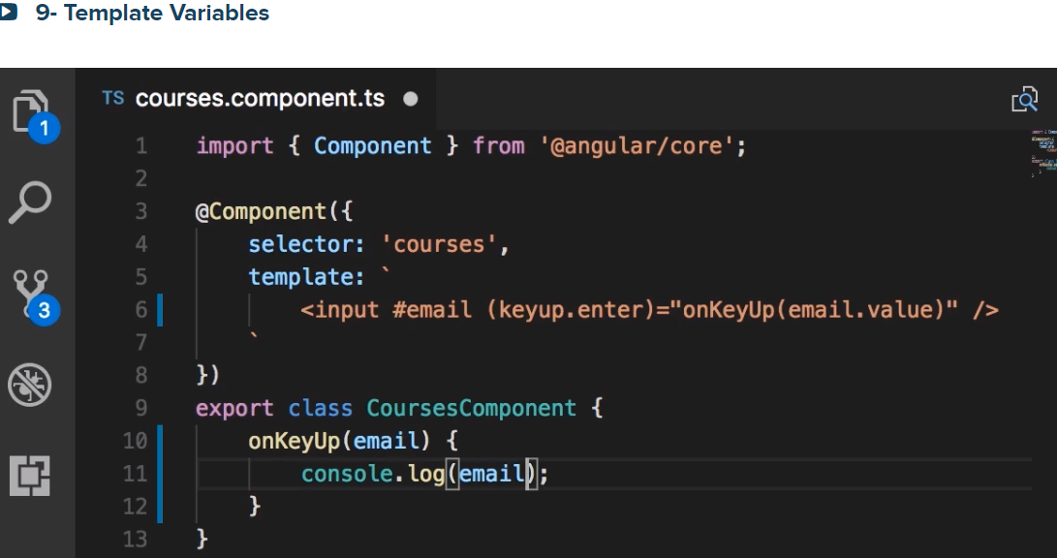

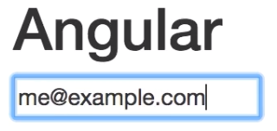 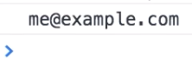

Next Two-way Binding

Now, we can bind the value property of this input object in DOM to the email field in CourseComponent class

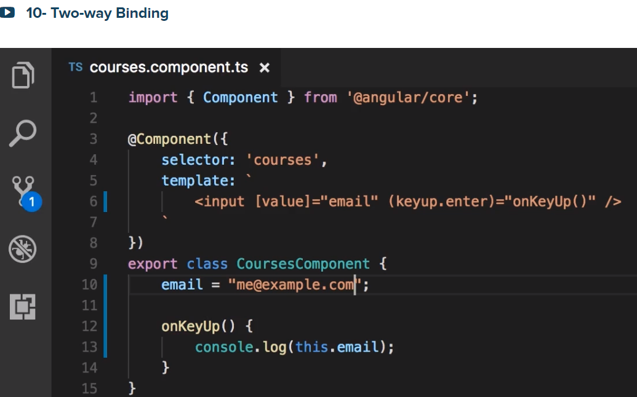

The input should be populated with this email address:

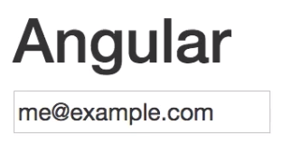

See we are passing data from the CourseComponent to the View.

Then from the above view it you change the email to [me@domian.com](mailto:me@domian.com) as show below:

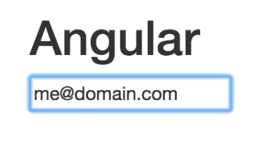

Your get 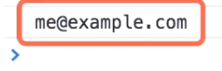

Why we could not get me@domian? Because the direction of the binding was from the component to the view

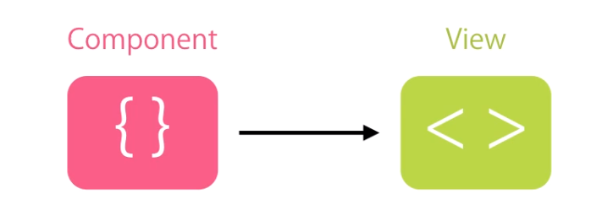

or

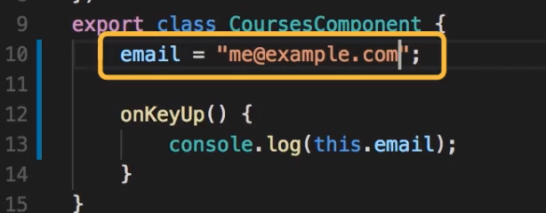

Here is a 2 way binding:

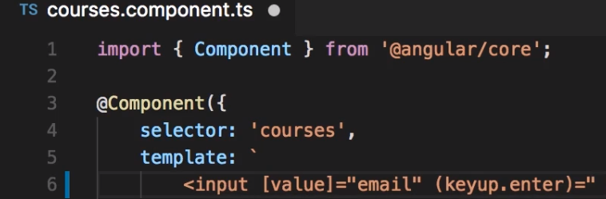



With this implementation we have 2-way binding:

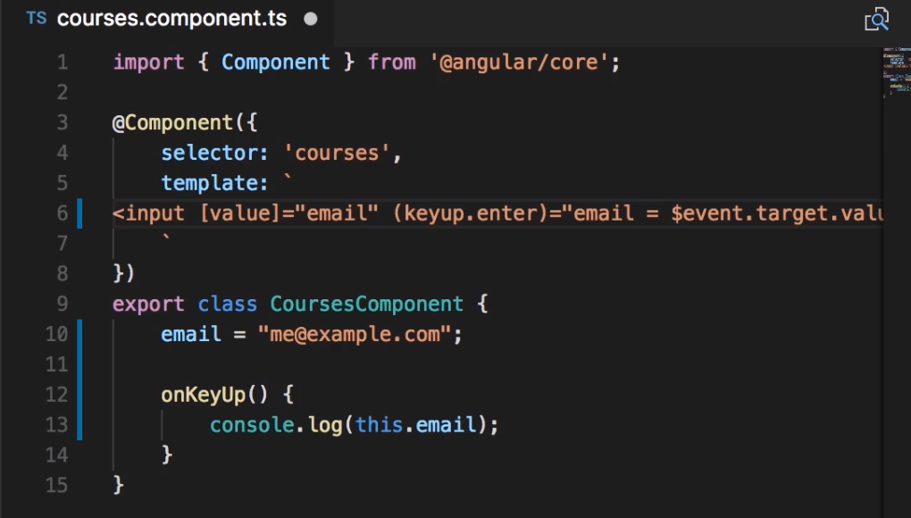



NgModule is in forms

look at the @NgModule

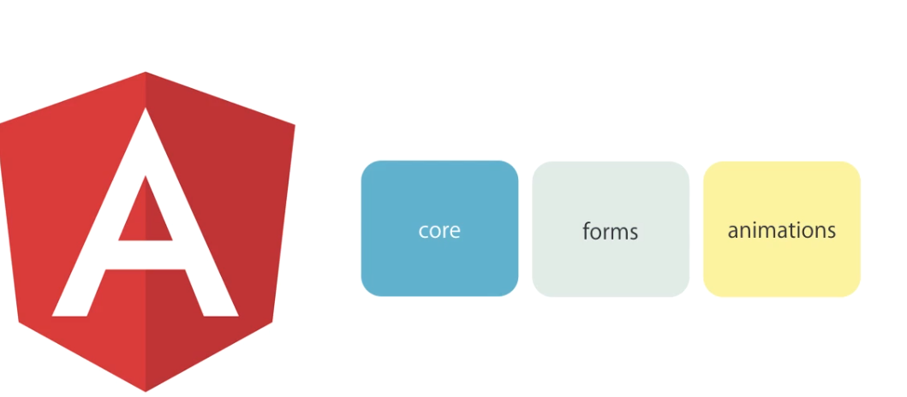There is also a better another way that we can use.

But first import @angular/forms in the app.module.ts as shown below:

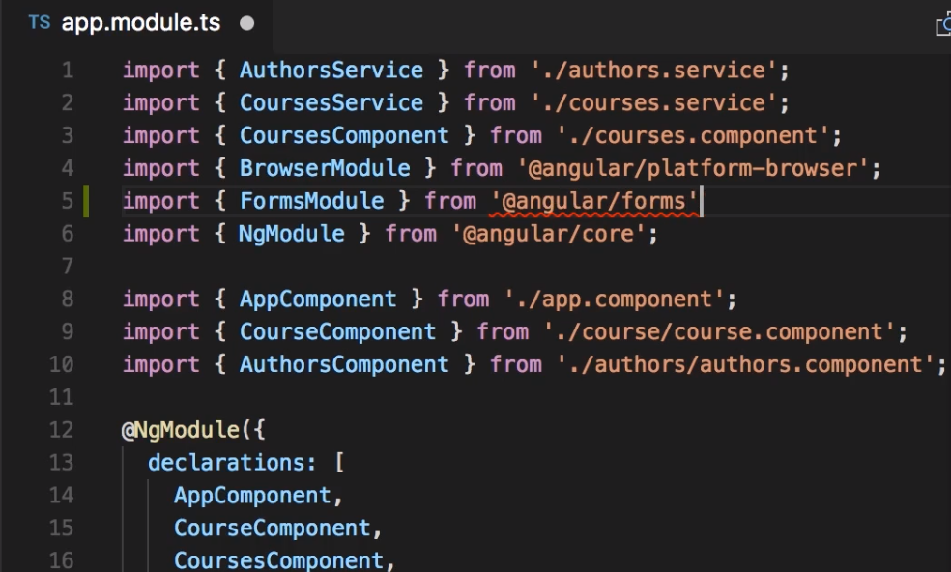

Look at imports array:

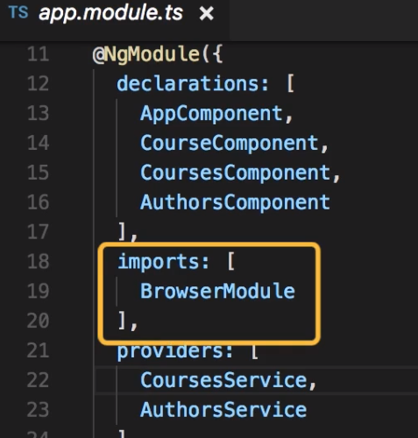

Now add the FormsModue:

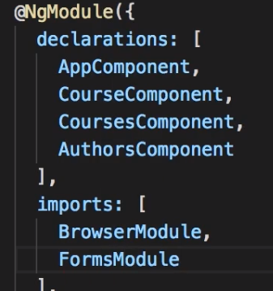

Then change your code as :

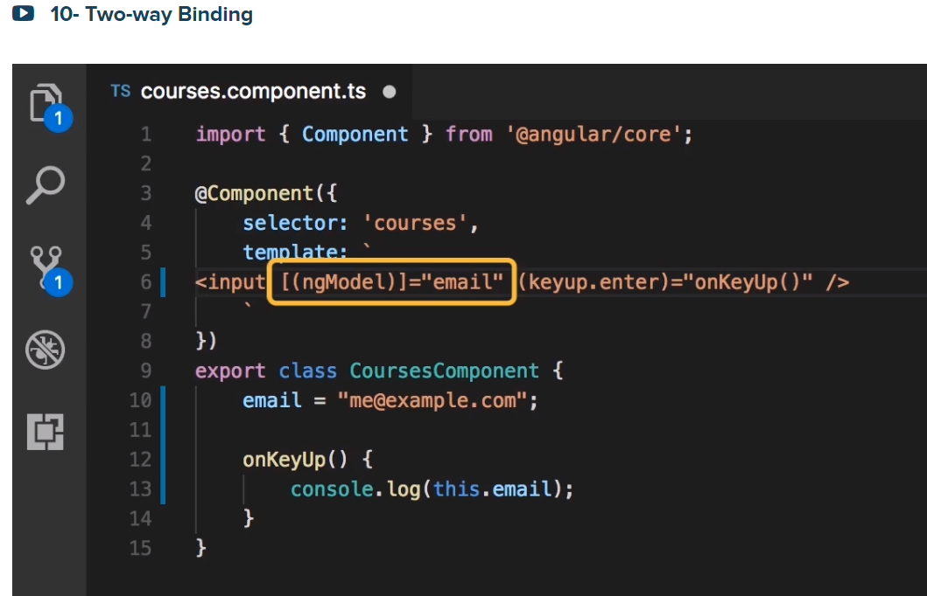

We got from the Component as :

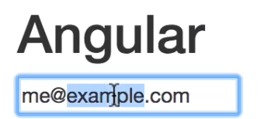

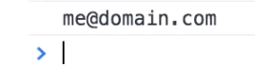

Pipes:

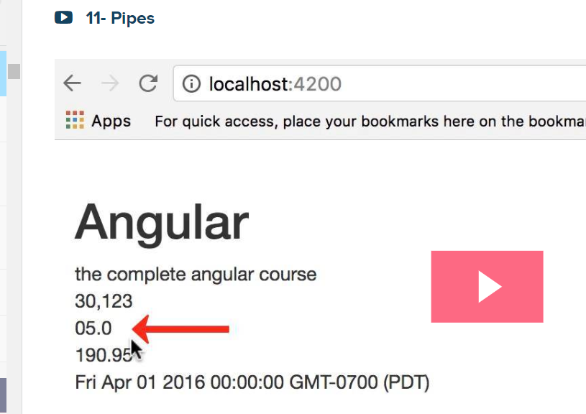

We use pipes to format data:

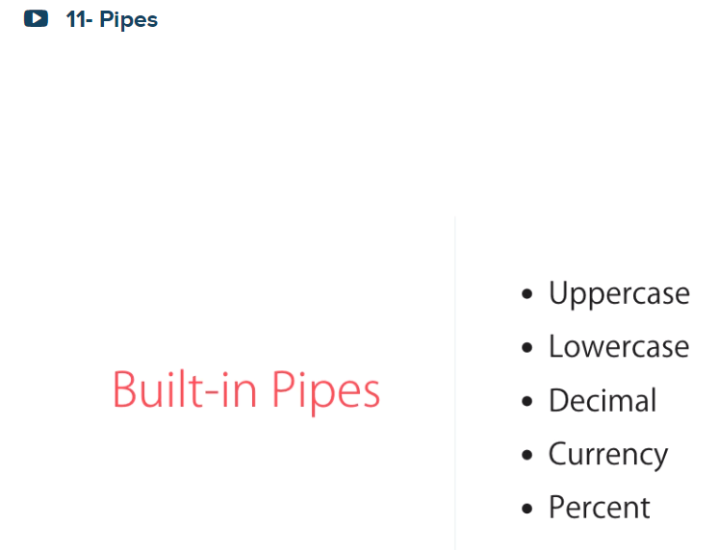

Before formatting:

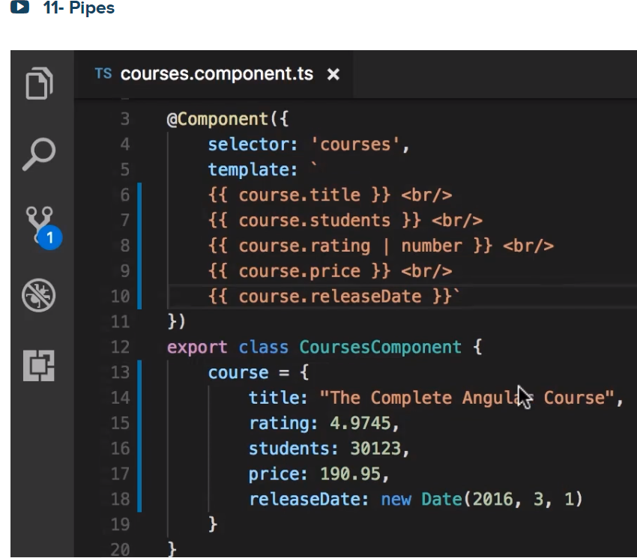

Then

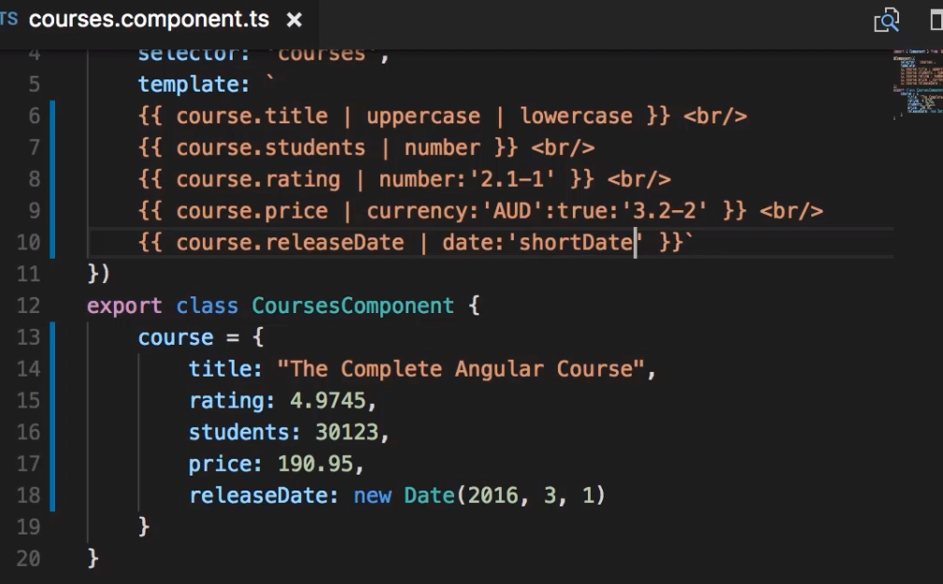

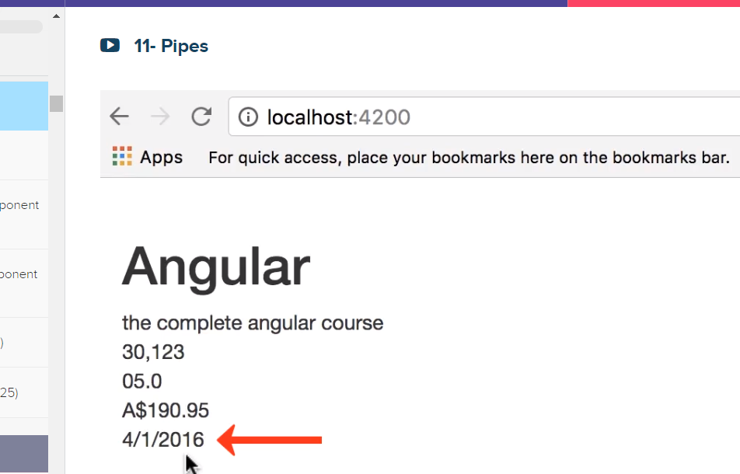

For see 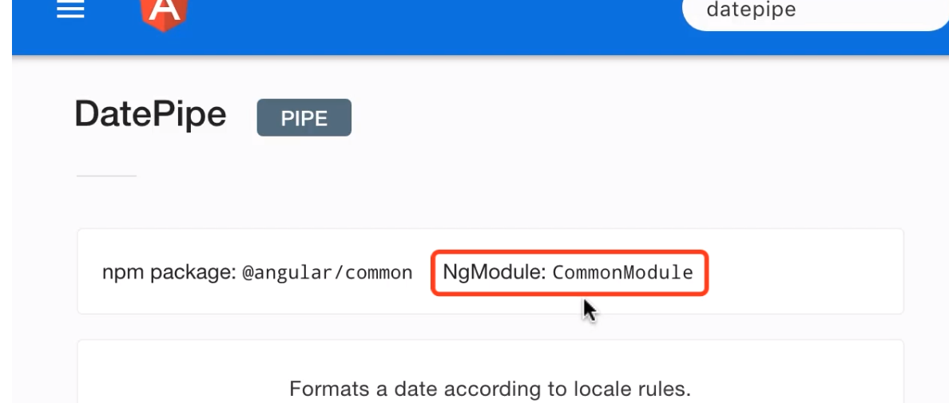

**Creating Custom Pipes**

Please note text in the CourseComponent is a very long text. Please summary it

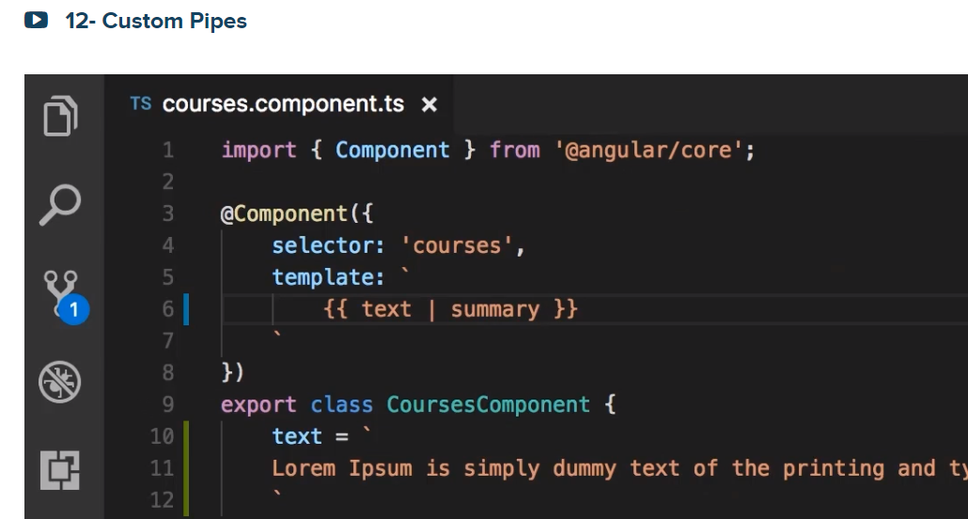

Create a “summary.pipe.ts” under app folder as shown below:

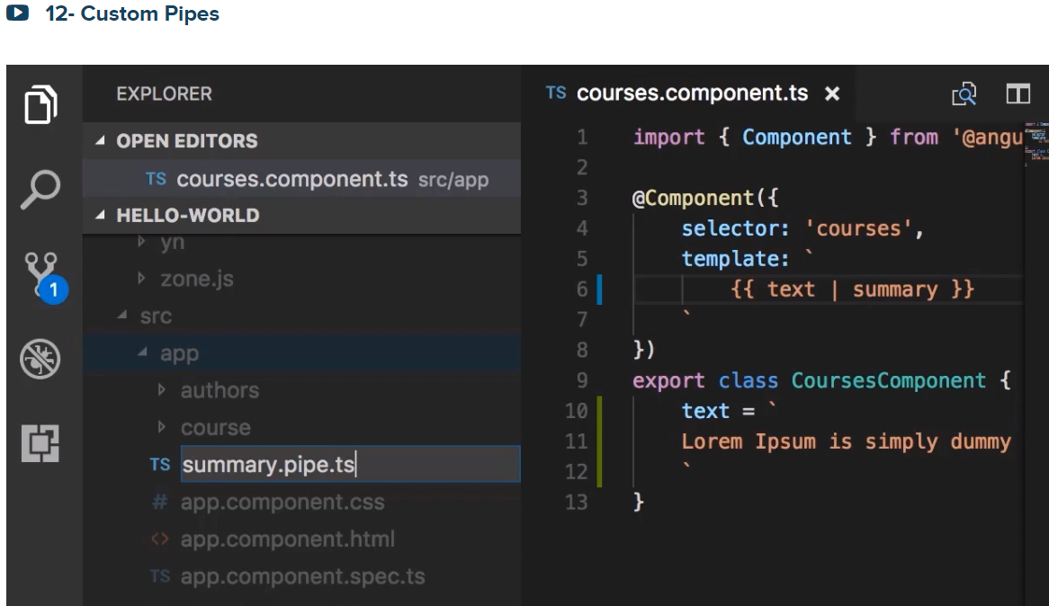

Then import 1) Pipe decorateor function and 2) PipeTransform which is a interface that defines the shape of all pipes in angular. See Apis below

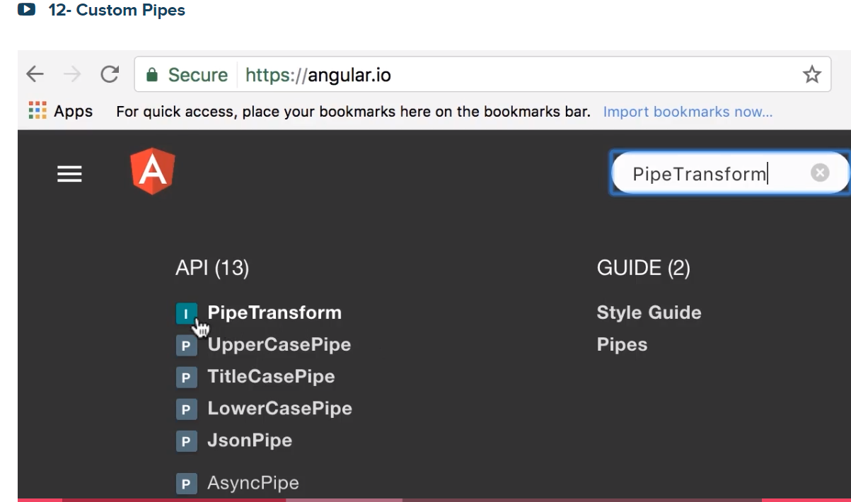

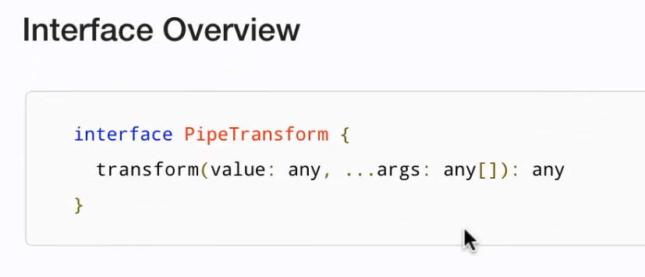

Then

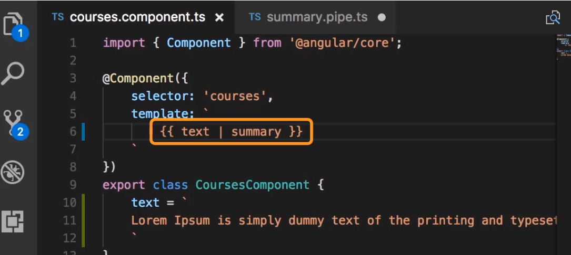

Then let us see a summary

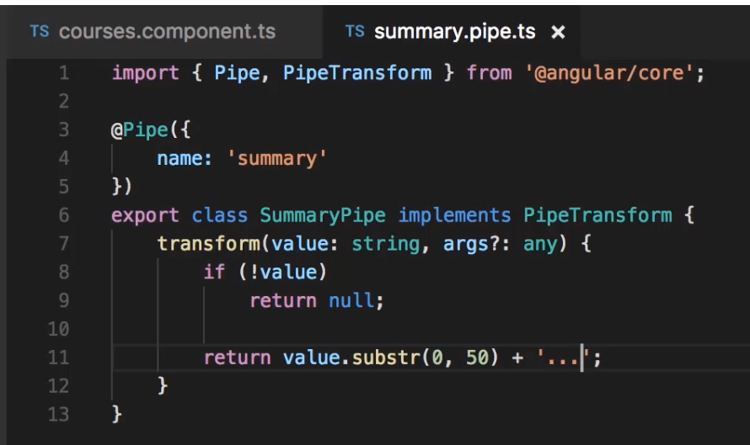

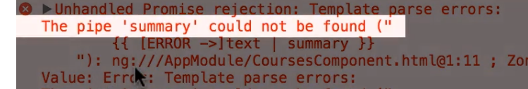

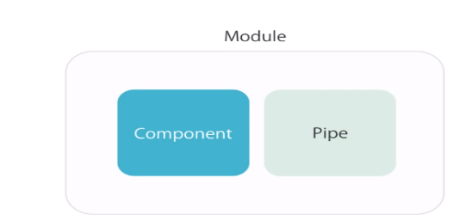

We forgot to register this Pipe in app module as we did for the Component: Look for the addition of

SummaryPipe in the @NgModule

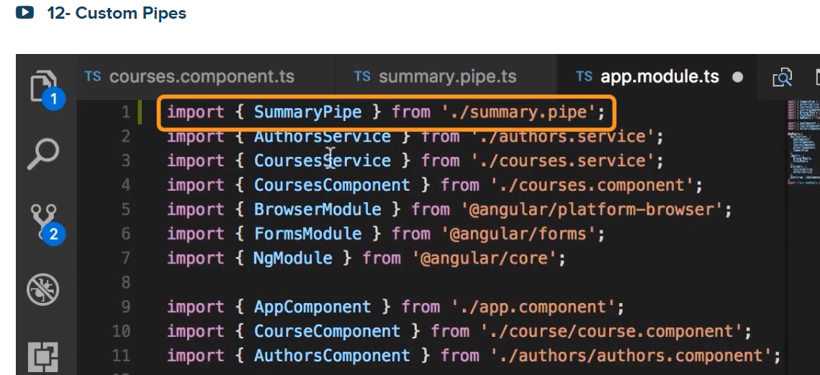

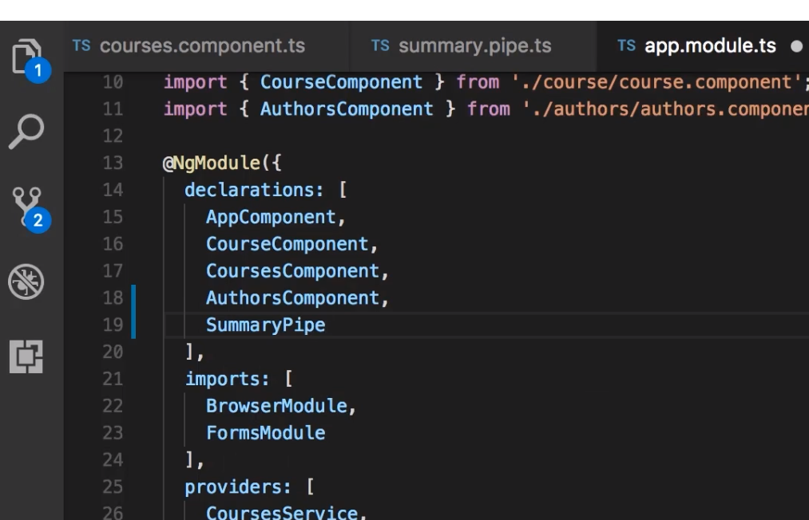

Output:

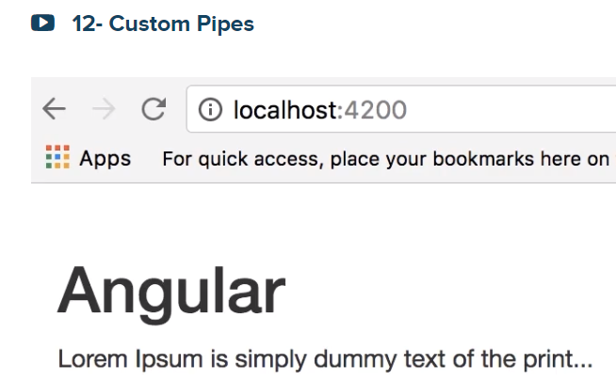

<https://getbootstrap.com/docs/3.3/components/>

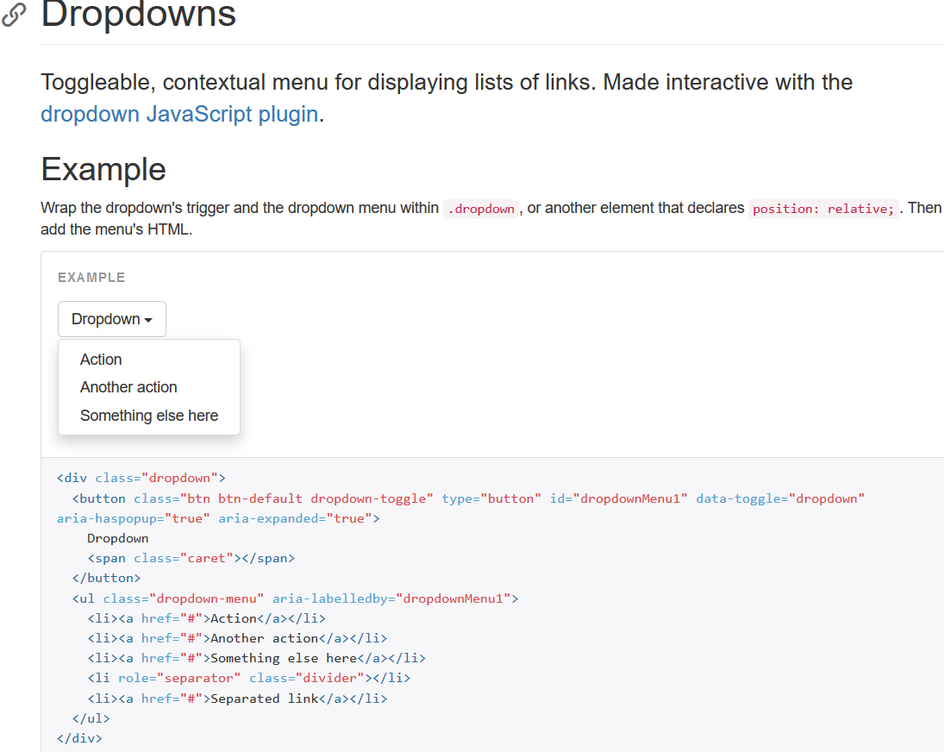

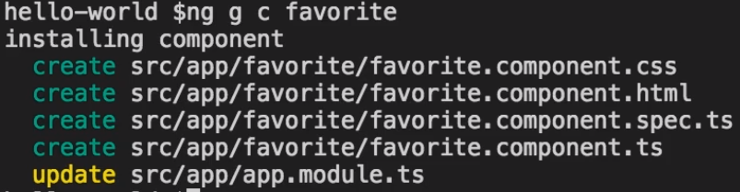

Title case

